Lab 3: Gather information & Vulnerability Scanning

Objective:
▪ Gathering information on the Internet.
▪ Understand and be proficient in using automated vulnerability scanning tools such as Nessus, OpenVAS, and Nmap.

Setup environment:
One machine for attacking purpose, and one machine that has vulnerabilities to exploit. Two machine must be on the same network.
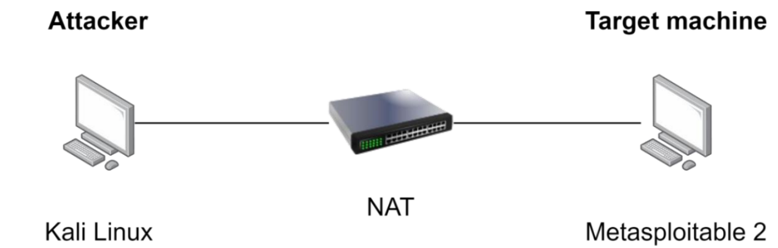

Progress:
Passive Information Gathering
Passive information gathering (also known as Open-source Intelligence or OSINT) is the process of collecting information about a subject through public means such as the Internet, magazines, newspapers, etc., without any direct interaction with that subject. There are two ways to gather information passively:
- Method 1: We will never interact directly with the subject. For example, we can rely on results from a third party to obtain information without accessing any of the subject's systems or servers. Using this method helps maintain confidentiality regarding our actions and intentions, but the disadvantage is that the search results may be limited.(Passive footprinting)
- Method 2: We can interact with the subject, but only as a normal Internet user. For example, if the subject's website allows us to register an account, we can do so. However, evaluating the website for vulnerabilities will not be included in this phase.(Proactive footprinting)
Website Reconnaissance
If the entity has a website, we can gather basic information by accessing their website. Small organizations may have only one website, while large organizations may have multiple websites. Therefore, gathering information from large organizations may take considerable time, but in return, we will obtain more information about that organization.

Task 1: Access this website https://www.megacorpone.com/ , then start the recon process.
Based on information from its official website, MegaCorp One is a pioneering corporation in the field of disruptive nanotechnology, specializing in developing and establishing industry standards for the medical, electronics, and commercial sectors. The company operates on a unique business model, beginning with the evaluation and subsequent acquisition of small, independent research groups with promising projects, thereby refining their technology for shared goals. Originating as a startup manufacturing computer microprocessors, their development of "bleeding edge" products helped popularize the term "nanotechnology." Today, MegaCorp One's technology applications are vast, ranging from medical devices such as cardiac pumps and cell regeneration nanomedicines to military applications such as smart weapons, serving both consumer and government markets. With a mission to foster an integrated world undivided by borders or currency, the company aims to create a society where technology and human life are inextricably linked.

Based on information from the website, this is a list of key members currently working at MegaCorp One:
Name | Position | Email Address | Social Media (Twitter Handle)
Joe Sheer | Chief Executive Officer (CEO) | joe@megacorpone.com | @Joe_Sheer / @joe_sheer
Tom Hudson | Web Designer | thudson@megacorpone.com | @TomHudsonMCO
Tanya Rivera | Senior Developer | trivera@megacorpone.com | @TanyaRiveraMCO
Matt Smith | Marketing Director | msmith@megacorpone.com | @MattSmithMCO
Mike Carlow | VP Of Legal | mcarlow@megacorpone.com
Alan Grofield | IT and Security Director | agrofield@megacorpone.com
Additional Details from Twitter Profiles:
Joe Sheer: Bio states "CEO, MegaCorp One | Leaders in Nano-Technology research and practical application." Account joined in August 2016.
Tom Hudson: Bio states "Lead Designer, Nano-Tech company." Account joined in August 2016.
Tanya Rivera: Bio states "Nanotech Lead Developer, MegaCorpOne | You think it, I can make it." The profile includes a link to the company's GitHub and notes that tweets are personal. Account joined in August 2016.
Matt Smith: Bio states "Marketing and Sales." Account joined in August 2016.

Based on an analysis of the email addresses for the listed members of MegaCorp One (joe@megacorpone.com, thudson@megacorpone.com, trivera@megacorpone.com, msmith@megacorpone.com), several observations can be made:
1. Standardized Corporate Format: All emails follow a consistent, professional format using the company's domain (@megacorpone.com). This indicates an established IT and corporate identity structure.
2. Predictable Pattern: The addresses use a common naming convention:
- First Name Pattern: For the CEO, Joe Sheer (joe@...).
- Initial + Last Name Pattern: For other members: first initial + full last name (e.g., t + hudson = thudson@).
3. Security & Profiling Implications: This predictable structure is standard for businesses but can be leveraged for:
- Email Enumeration: It could be used to guess the email addresses of other employees not publicly listed (e.g., jsmith@, awilliams@).
- Targeted Phishing: Knowledge of this format and employee names makes crafting convincing spear-phishing emails easier for malicious actors.
- Organizational Mapping: It helps confirm an individual's association with the company and can aid in building a profile of its staff structure.
Conclusion: While the email format itself is normal business practice, its predictability combined with publicly available employee names creates a minor information security consideration, as it simplifies the process for external parties to contact, profile, or potentially target company personnel.

Whois Enumeration
Whois is a TCP service, tool, or database that can provide information about domain names such as:
Name servers (the DNS addresses pointing to the domain name), registrar (the domain name administrator, usuallyorganizations or corporations that distribute domain names by extension such as Verisign, Mat Bao, Namecheap, Godaddy, ...), domain name registration date... We can collect basic information about domain names using the whois tool.
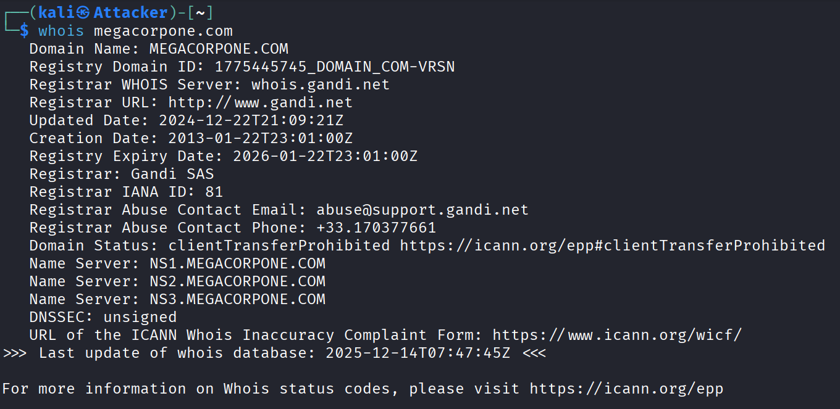
Not all the data is useful, but we were able to obtain some valuable information. First, the whois results show that Alan Grofield is the domain name registrant. Based on the company's profile page, we know that Alan is an "IT and Security Director".
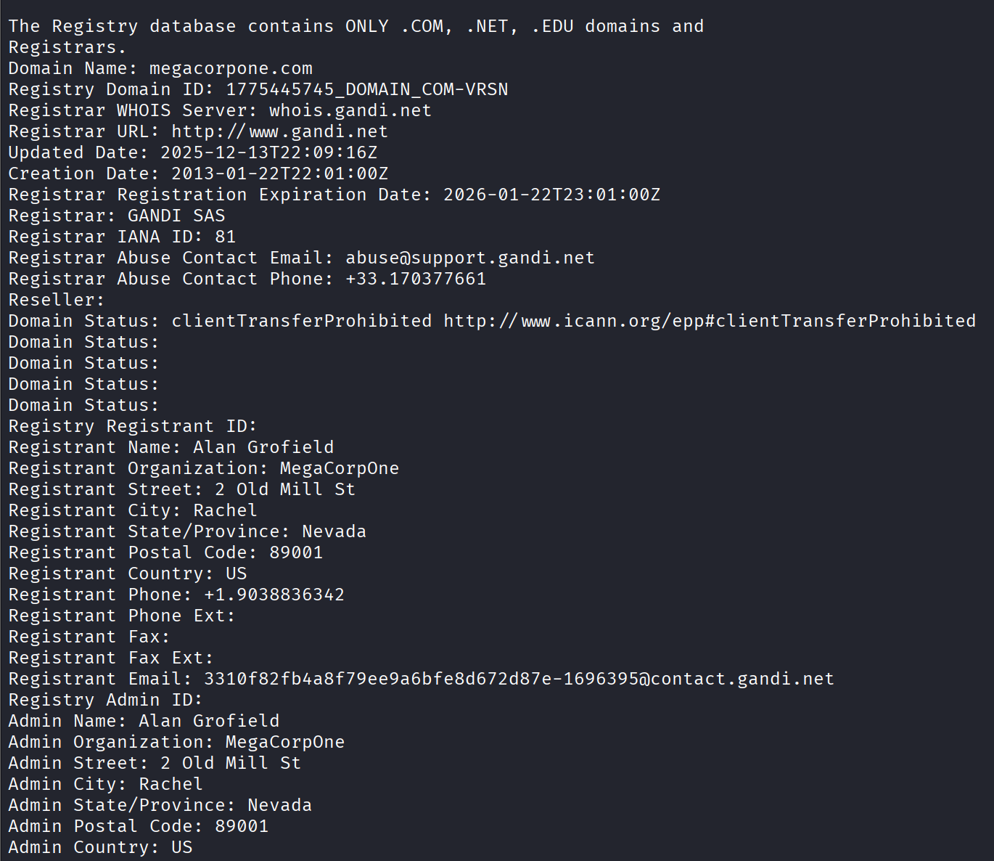

Task 2: Using Whois tools
The whois results tell us about the name servers of MegaCorp One. Name servers are one of the components of DNS.


We cannot use Whois to find information about uit because the .vn top-level domain does not provide a public WHOIS service over the standard TCP port 43, unlike generic TLDs such as .com or .net. The .vn namespace is managed by the Vietnam Internet Network Information Center (VNNIC), which restricts WHOIS access to web-based lookup services or non-public internal APIs. As a result, standard Linux WHOIS tools are unable to query registration data for .vn domains. It is also important to note that .edu.vn is not a top-level domain; the actual TLD is .vn, while edu.vn is a second-level domain administered by VNNIC, and uit.edu.vn is a third-level domain. Consequently, WHOIS queries for such domains must be handled by VNNIC rather than by global registries such as IANA or Verisign.
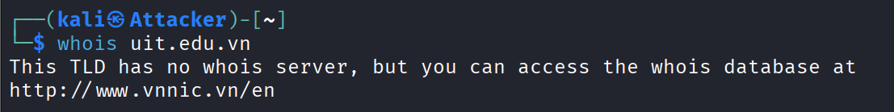

Due to registry restrictions, the .vn top-level domain does not provide public WHOIS access via the standard TCP port 43. Therefore, domain registration information for uit.edu.vn was obtained using the official web-based WHOIS service provided by the Vietnam Internet Network Information Center (VNNIC), which is the authoritative registry for the .vn namespace.
Tool used: VNNIC WHOIS (Web-based)
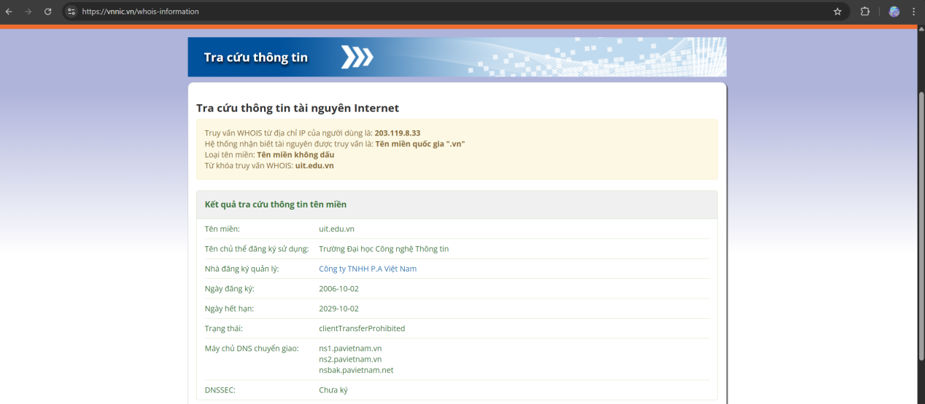
Results obtained:
Domain name: uit.edu.vn
Domain owner: University of Information Technology
Registrar: P.A Vietnam Co., Ltd.
Registration date: 2006-10-02
Expiration date: 2029-10-02
Domain status: clientTransferProhibited
Name servers:
ns1.pavietnam.vn
ns2.pavietnam.vn
nsbak.pavietnam.net
DNSSEC: Not signed

Also I really care about attack surface so I did a small subdomain enumeration for uit and achived this.
Fetching subdomains for: uit.edu.vn
tech4covid.uit.edu.vn
www.tech4covid.uit.edu.vn
app2.iot.uit.edu.vn
app1.iot.uit.edu.vn
netsens.uit.edu.vn
519bb137df6144dcbeda18e87d53ad8a-0-s-80.vlab.uit.edu.vn
api.mmlab.uit.edu.vn
notebook.uit.edu.vn
tcvaccine.uit.edu.vn
hcmccovidsafe-dev-gw.tech4covid.uit.edu.vn
hcmccovidsafe-dev.tech4covid.uit.edu.vn
www.hcmccovidsafe-dev-gw.tech4covid.uit.edu.vn
www.hcmccovidsafe-dev.tech4covid.uit.edu.vn
console-cloud.vlab2.uit.edu.vn
overleaf.inseclab.uit.edu.vn
service.aiclub.cs.uit.edu.vn
eth2.uit.edu.vn
inseclab.uit.edu.vn
phongdl.uit.edu.vn
console-cloud.vlab.uit.edu.vn
tutorials.aiclub.cs.uit.edu.vn
www.tutorials.aiclub.cs.uit.edu.vn
xncovid.uit.edu.vn
dsc.uit.edu.vn
nlp.uit.edu.vn
www.service.aiclub.cs.uit.edu.vn
hcmccovidsafe.tech4covid.uit.edu.vn
www.hcmccovidsafe.tech4covid.uit.edu.vn
annotation.mmlab.uit.edu.vn
uit.edu.vn
a084742fa316491c8c78564efcbce9e0-68f6236f-vm-80.vlab2.uit.edu.vn
competitions.uit.edu.vn
app.tech4covid.uit.edu.vn
student.cs.uit.edu.vn
testbed.iot.uit.edu.vn
nc.uit.edu.vn
cs.uit.edu.vn
khmt.uit.edu.vn
cbsv1.uit.edu.vn
hcmccovidsafe-gw.tech4covid.uit.edu.vn
Subdomains were enumerated using an automated subdomain discovery tool (argus) as part of the information gathering phase. The results reveal multiple services, research labs, development environments, and application endpoints associated with the uit.edu.vn domain.

Google Hacking
The term “Google Hacking” became popularized by Jonny Long in 2001. He pointed out how search engines like Google could obtain critical information and vulnerabilities from misconfigured websites.
Let's try some basic keywords. Site keywords only perform searches on a specific domain.


The keyword filetype (or ext) is used to display only results with the specified file extension.


We can add the character "-" to exclude unwanted search results.
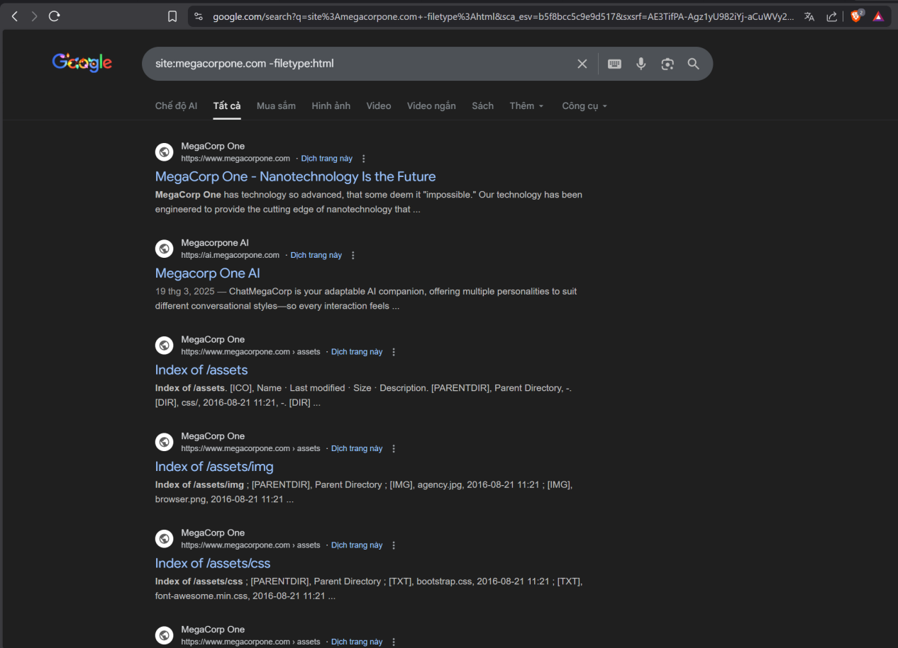

The basic examples above are just some of the common keywords. Google Hacking Database (https://www.exploit-db.com/google-hacking-database) contains many keywords that are frequently used during the data collection phase of a target.
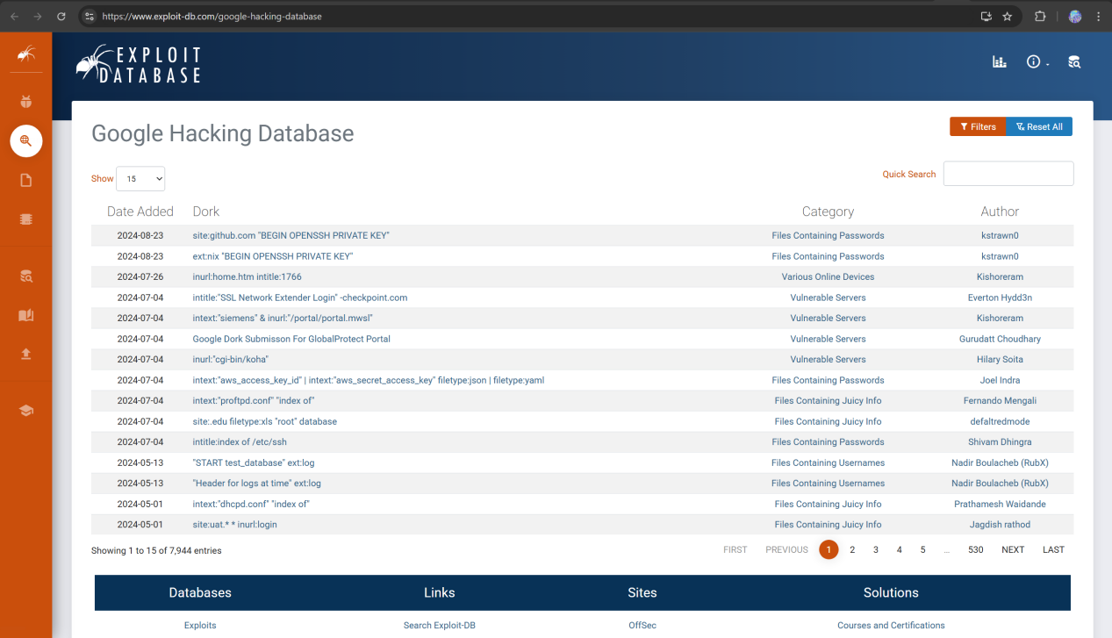

Task 3:
The Vice President of Legal of MegaCorp One is Mike Carlow, and his email address is mcarlow@megacorpone.com .
Using the simple google dork site:megacorpone.com "@megacorpone.com", I can find the assets folder of MegaCorp One that the web does not show, then I can view all the images that are not on the website, and find 4 pictures of 4 members that are not on the introduction of website.
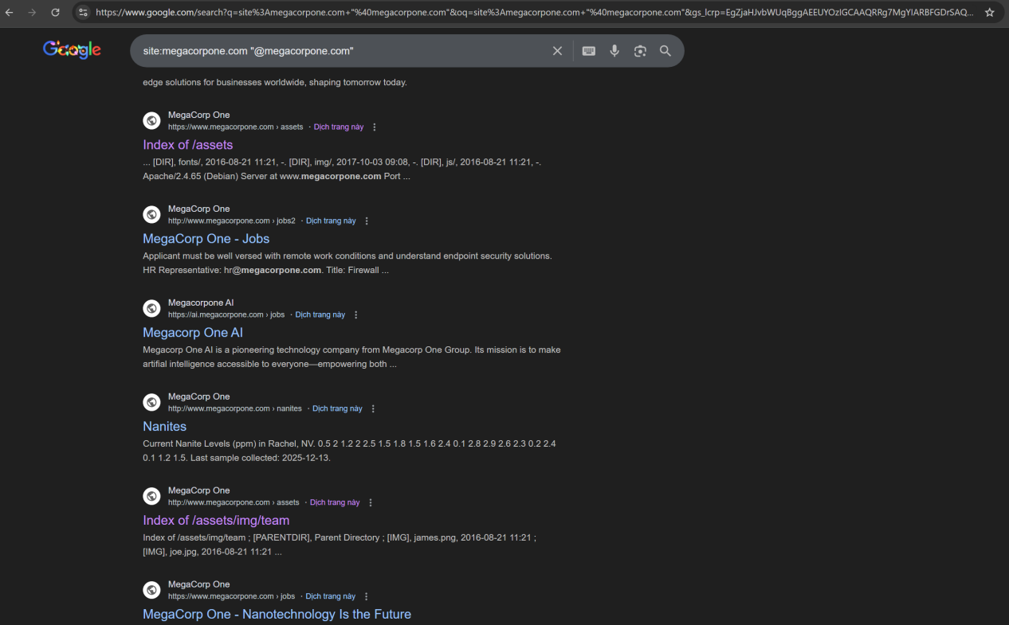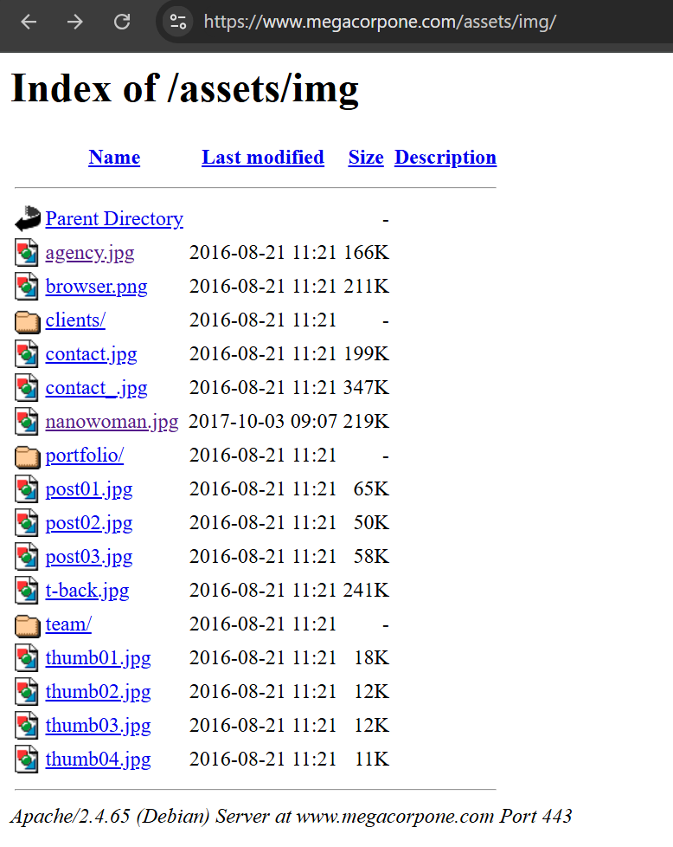

In the context of Google Hacking, commonly used keywords refer to advanced Google search operators, also known as Google dorks. Examples include site: for domain-restricted searches, filetype: for locating specific file formats, intitle: for matching page titles, inurl: for identifying keywords in URLs, and intext: for searching within page content.
In order to find some interesting files from UIT, I used google dork with these arguments:
site:uit.edu.vn filetype:pdf
site:uit.edu.vn filetype:doc
And after a while, searching for pdf file I have found some pdf files that cannot be accessed normally on the uit foru, but if I have the link, I can download it easily. This is the heath insurance, student’s dept, subject record information about UIT students 12 years ago
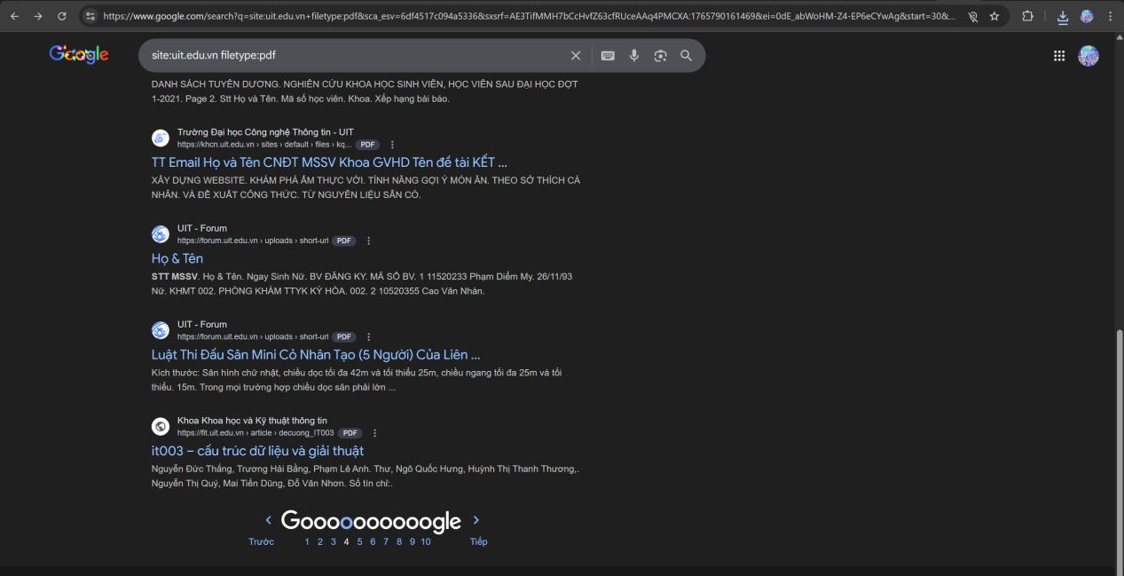
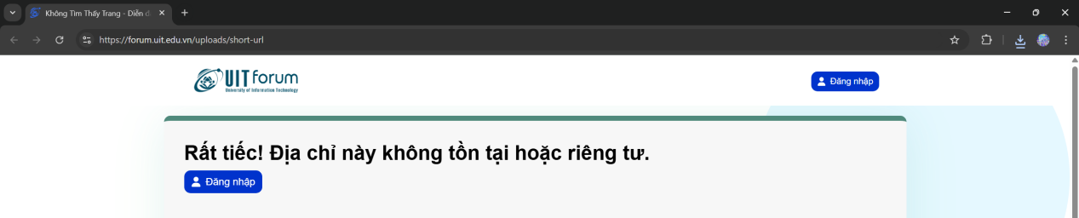

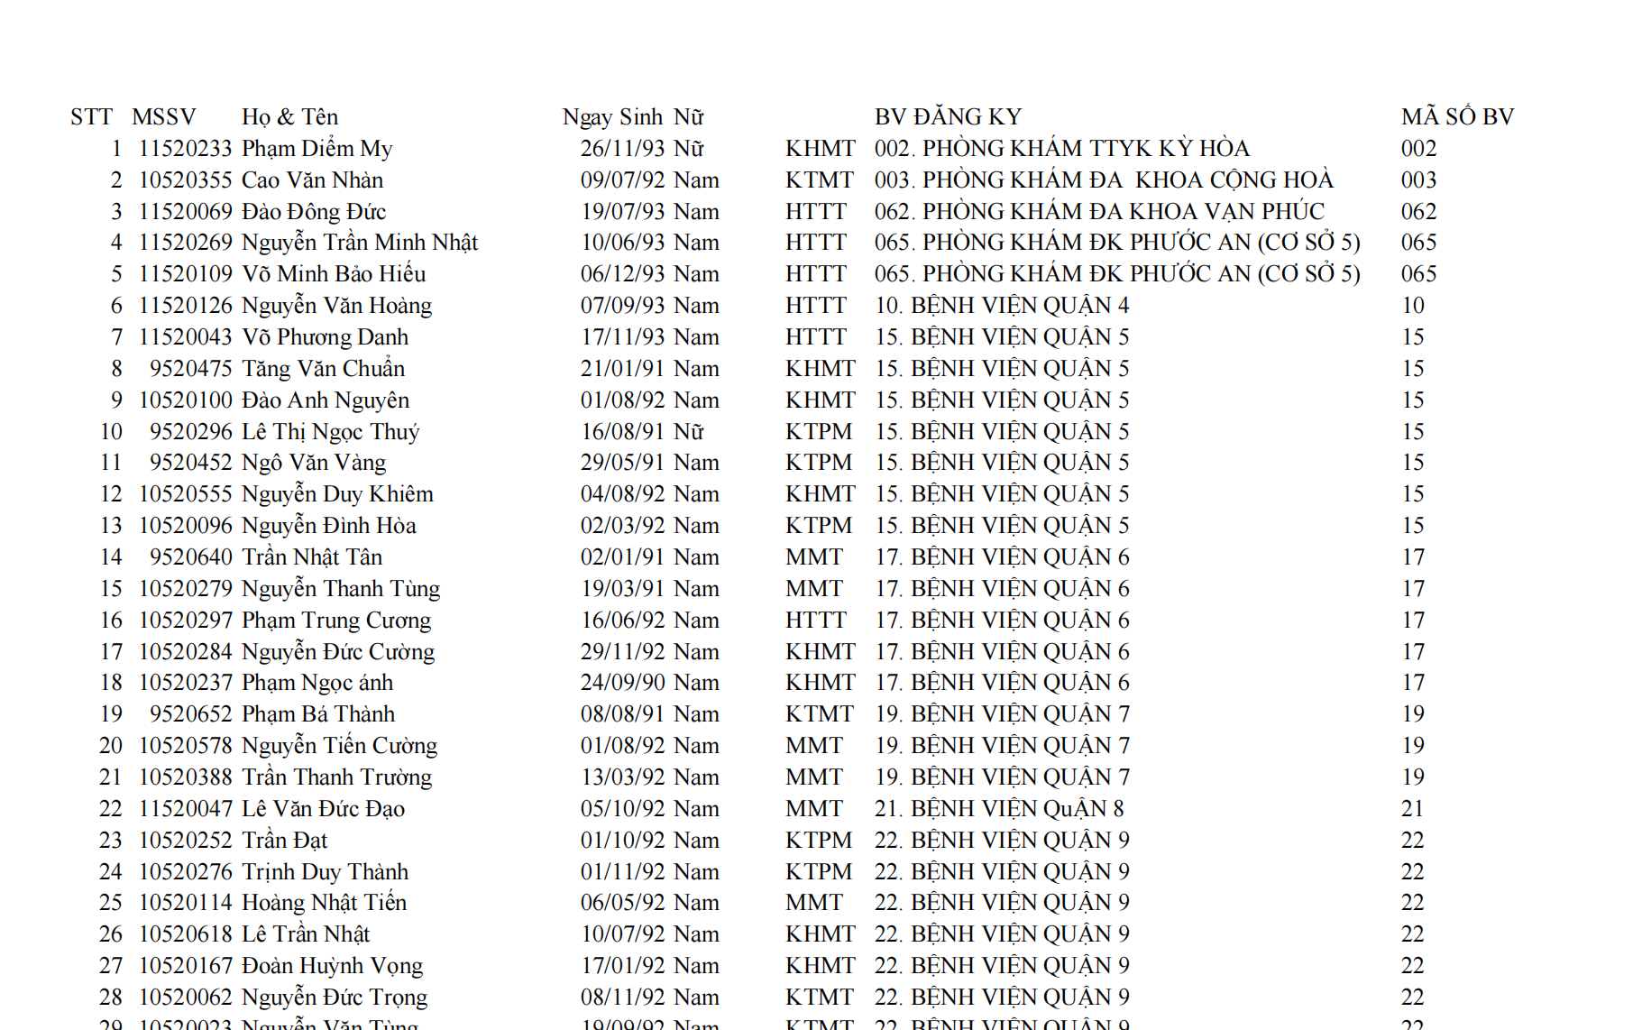

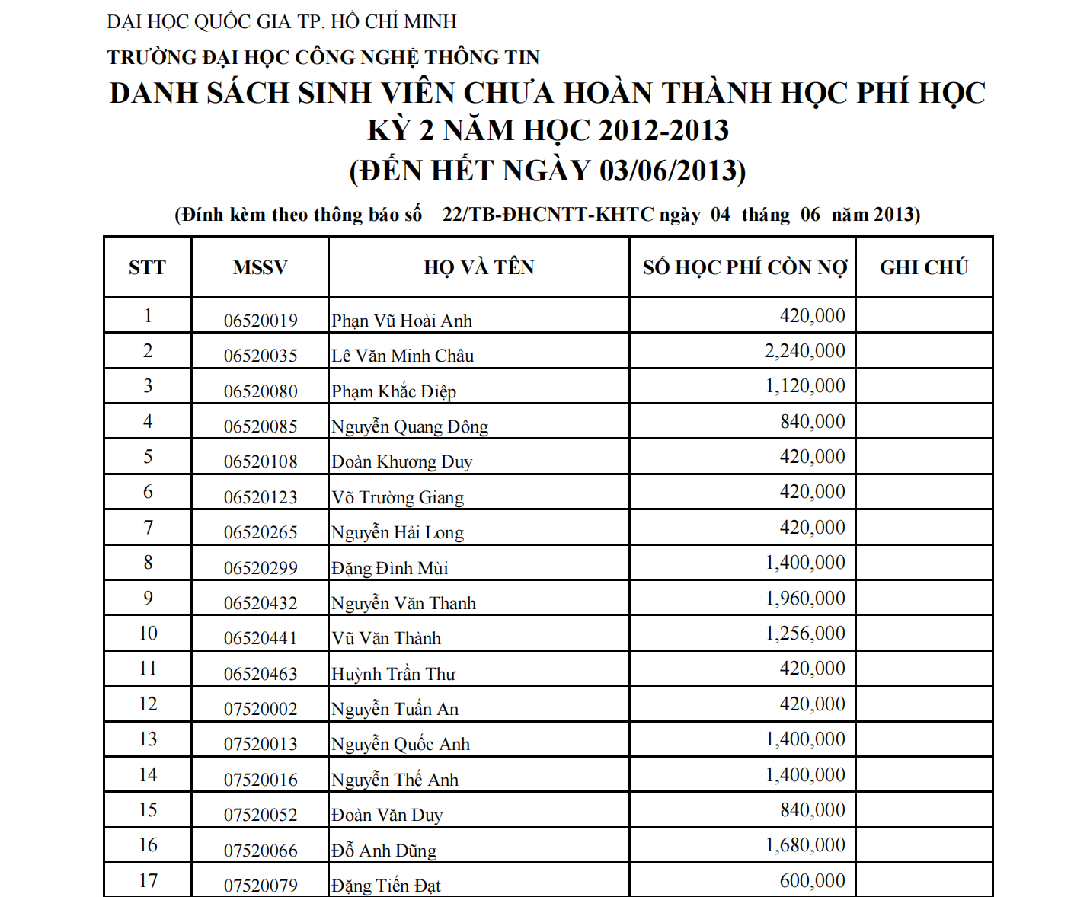
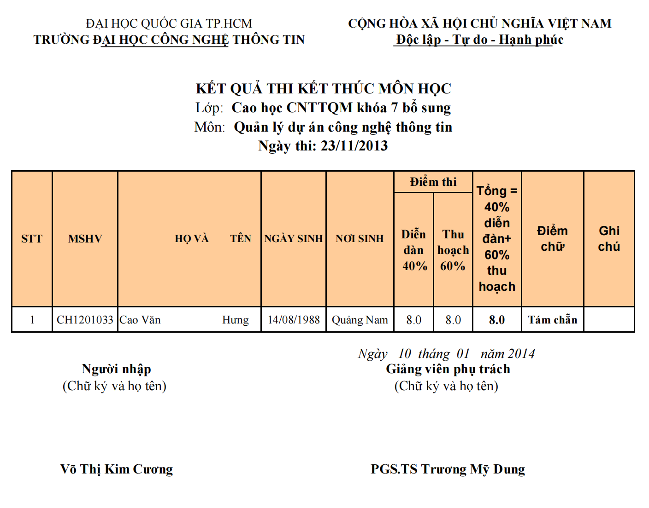
Netcraft
Netcraft is an internet services company based in the UK that provides a free information portal performing various data collection functions. Using services like those offered by Netcraft is considered a passive data collection technique because we never directly interact with the subject.
For example, Netcraft provides a service to search for DNS information related to the domain name to be collected (https://searchdns.netcraft.com/).
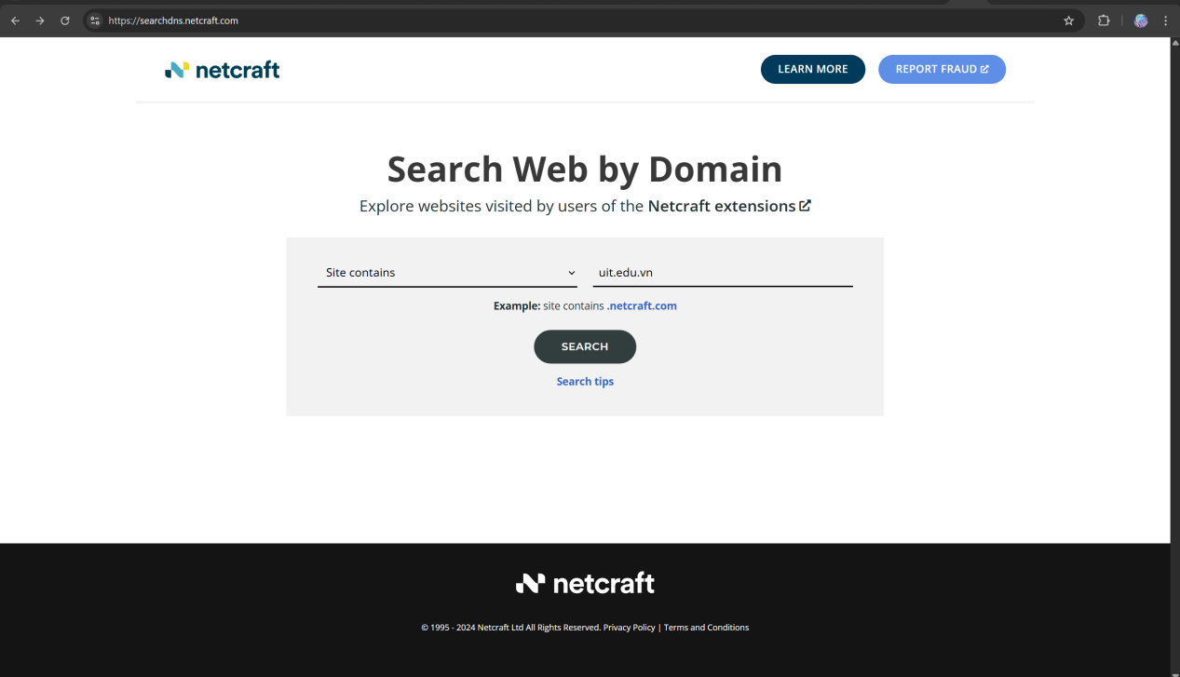
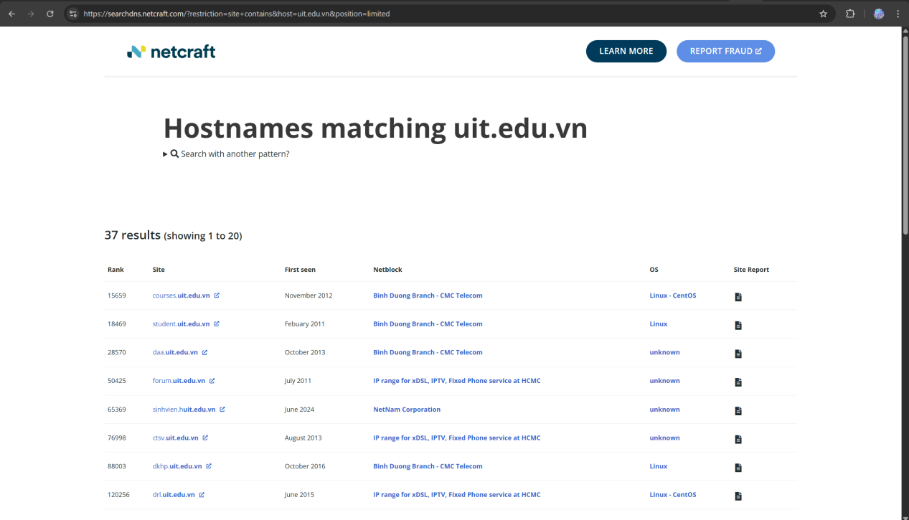
For each server found, we can view additional information and history about the server using the "Site Report" feature.
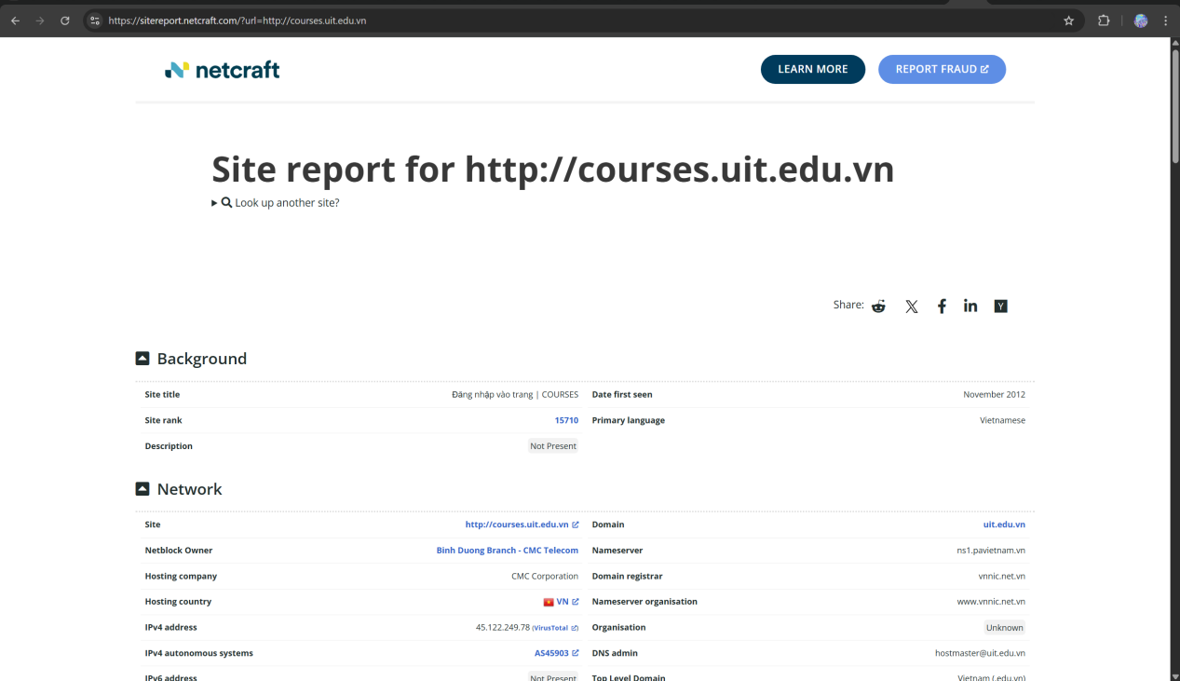

Task 4: Use Netcraft to identify the application server running
on www.megacorpone.com
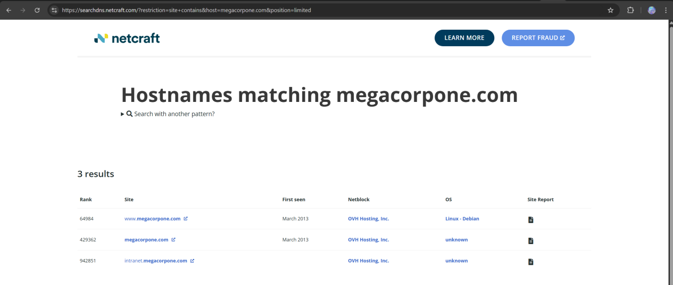
The results indicate that the application server is running on a Debian-based operating system with Apache as the web server software. This information reveals details about the server-side environment and underlying infrastructure, which could potentially be useful during the reconnaissance phase of a security assessment.
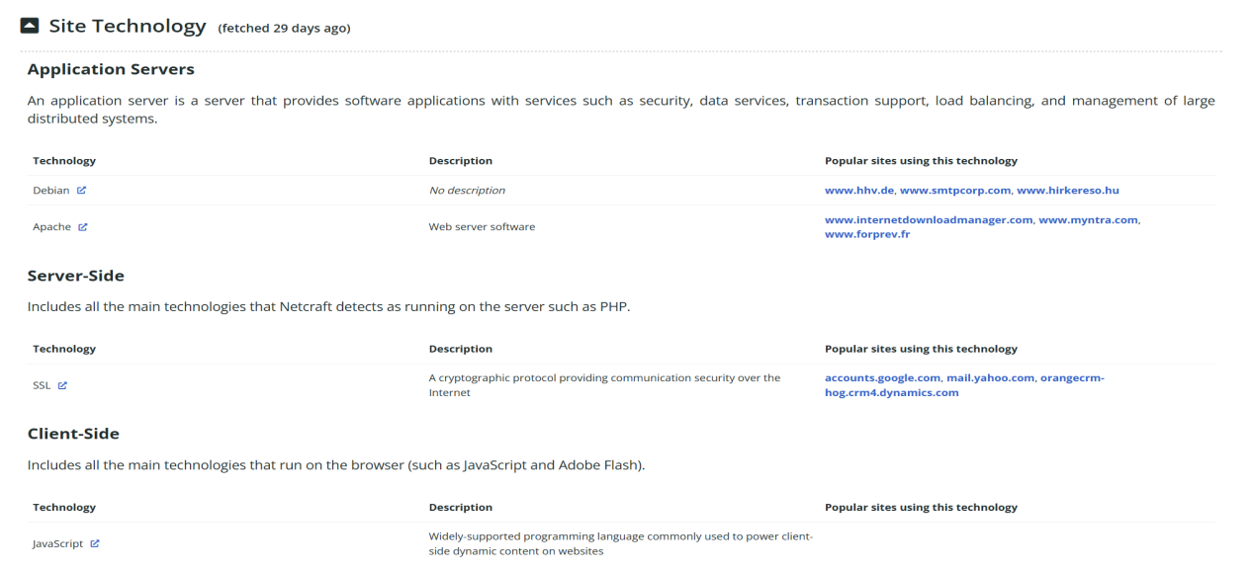
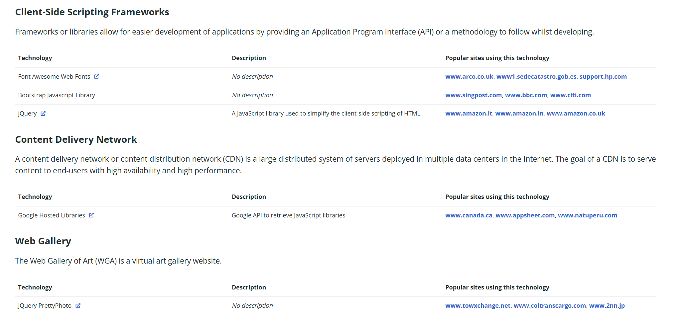
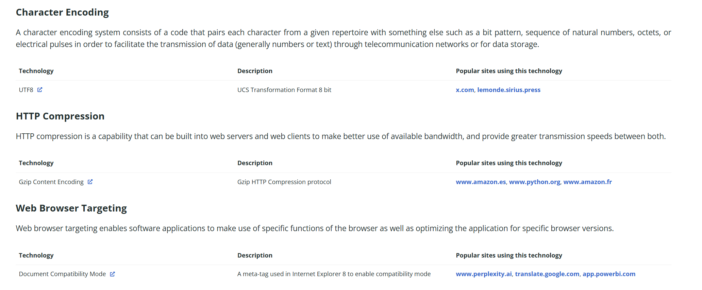
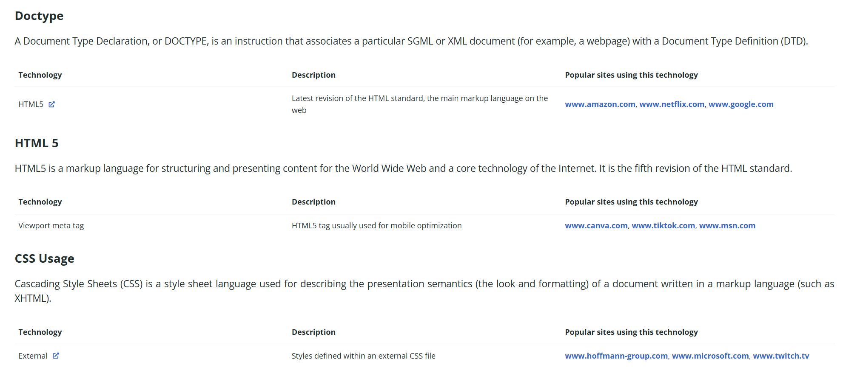
Recon-ng
Recon-ng is a modular platform for web-based data collection. Recon-ng displays results in the terminal or a database. The strength of recon-ng is its ability to feed results from one module as input to another, allowing us to quickly expand the scope of our data collection. To use it, execute the command “recon-ng”.
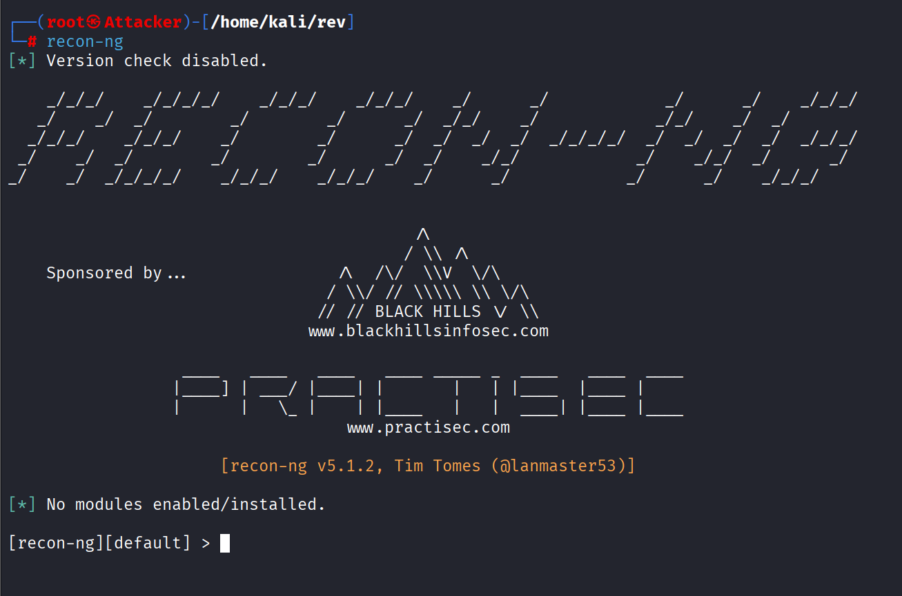
According to the results after starting recon-ng, we need to install additional modules to be able to use recon-ng. We can add modules from the "Marketplace". Use the command “marketplace search” to find recon-ng modules.
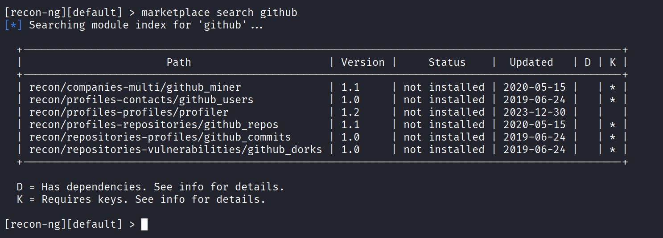
Note the “K” column; we see several modules marked with an asterisk (*). These modules require login credentials or API keys from third-party vendors. Some keys are free if you register an account, while others require payment.
Use the command “marketplaceinfo” to find module information.
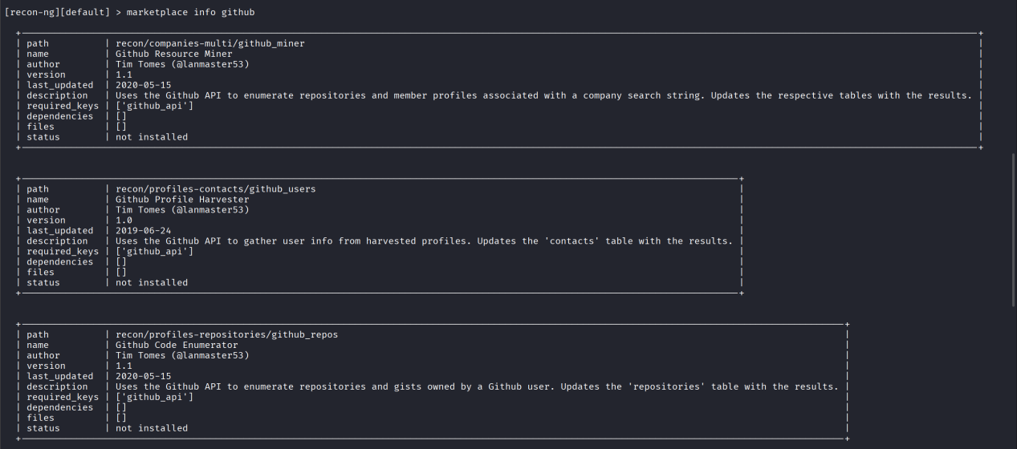
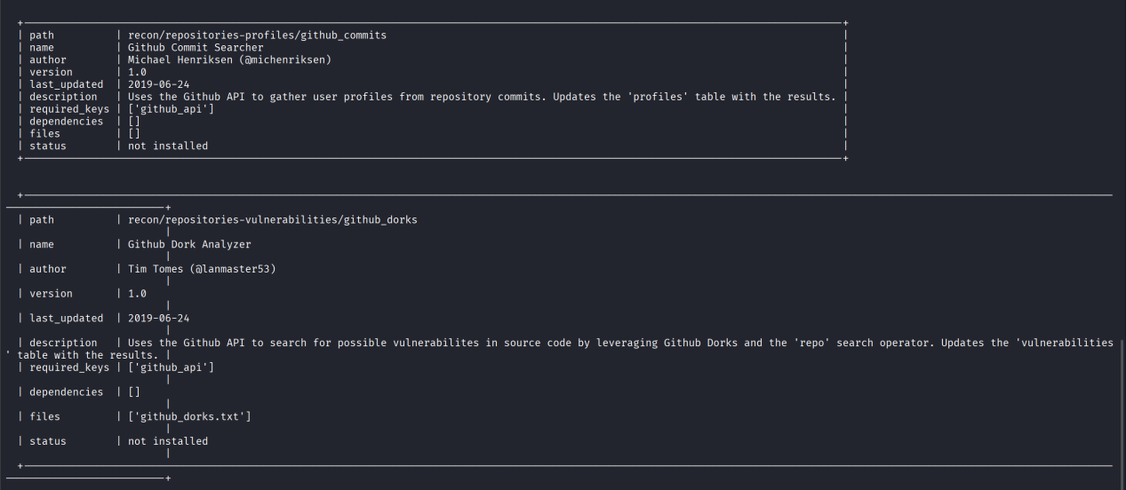
Above are the modules that need key.
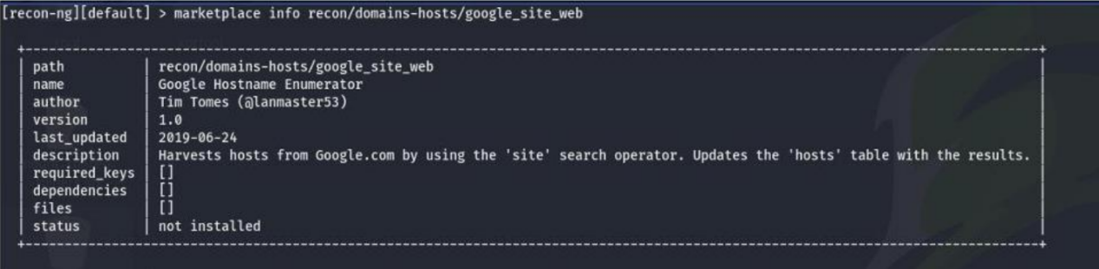
This is the one that does not need key.

Use the command “marketplace install” to install the modules. Here I want to install all modules to test out. Also some modules that need key will appear errors, but lets do not care about it.
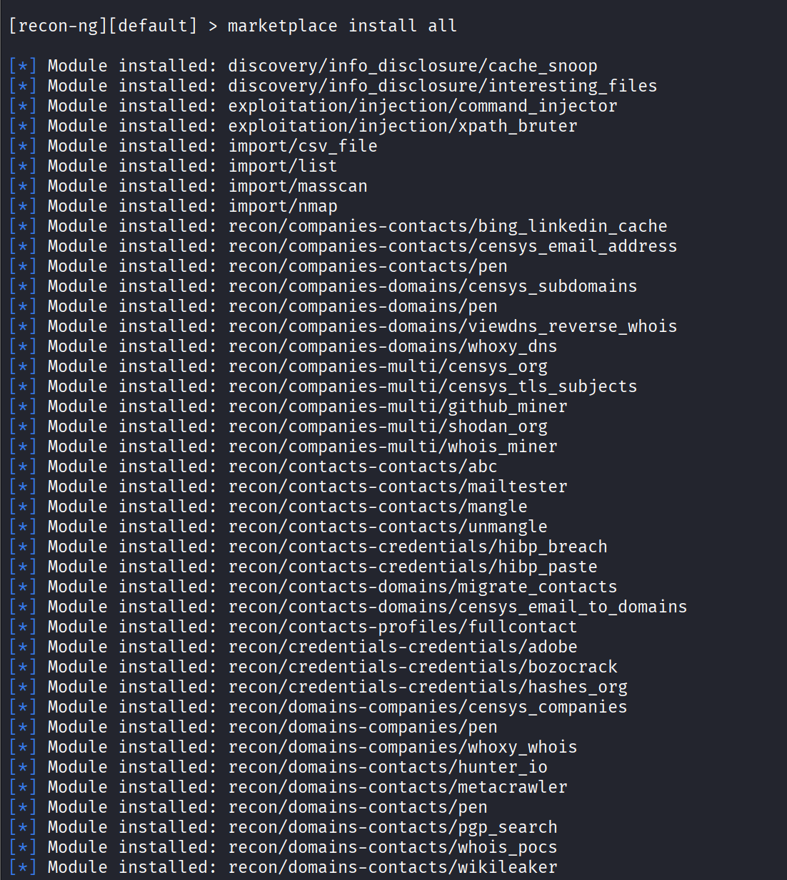

After installing the module, use the “modules load” command to use it. Then use the “info” command to display detailed information about the module and the required parameters.
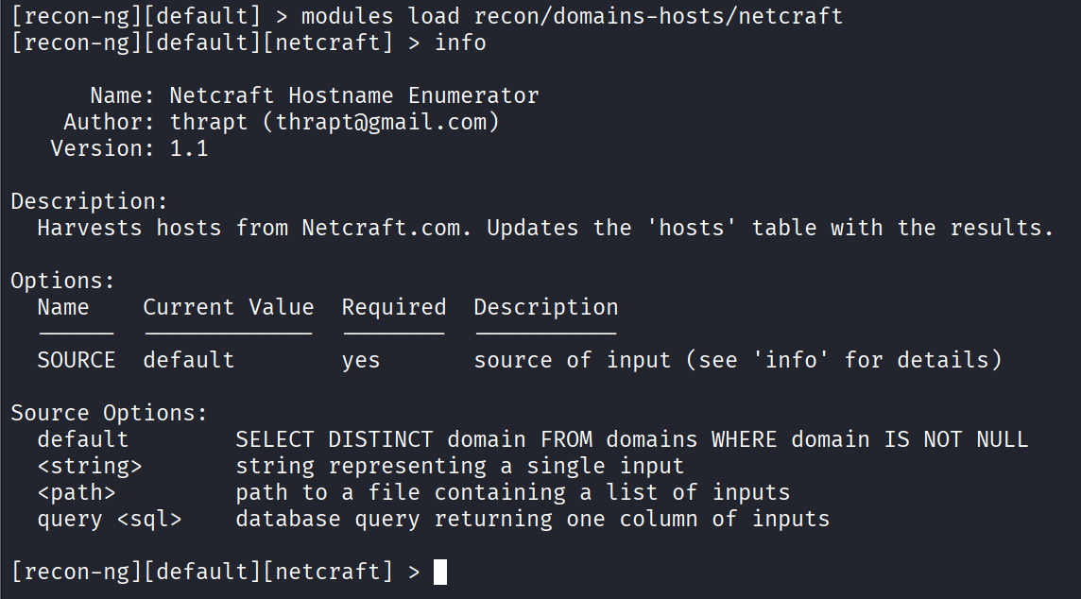
This module requires the input parameter “SOURCE”, which is the object from which we need to collect information. In this case, use the command “options set SOURCE megacorpone.com” to set the domain name of the target.

Use the command “run” to start the module.
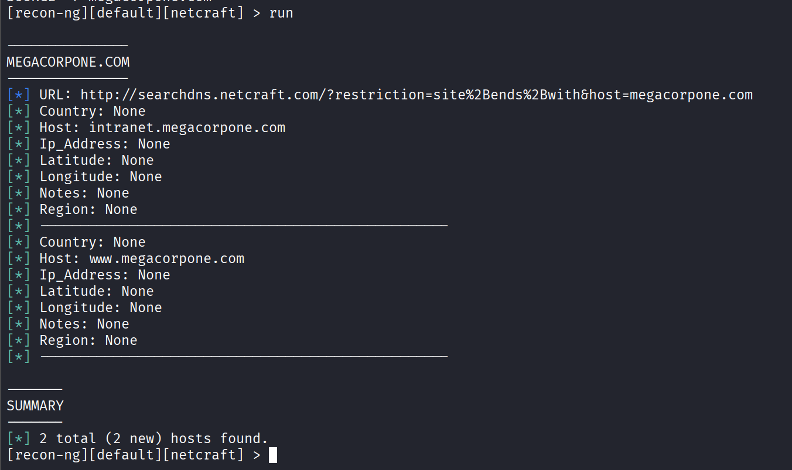

Use the “show hosts” command to view the history of the hosts that have been found.
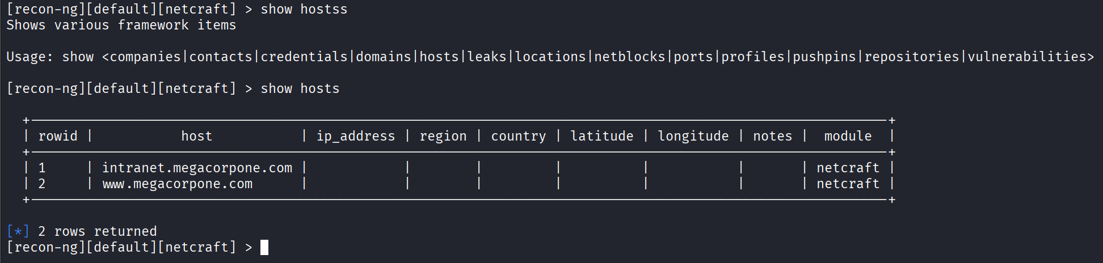

Task 5:
In the first part of task 5, I will use modules in recon-ng to find all the domain name ò megecorp.com and then resolve its domain name to its IP address.
FIrst, lets create a workspace to work with it.
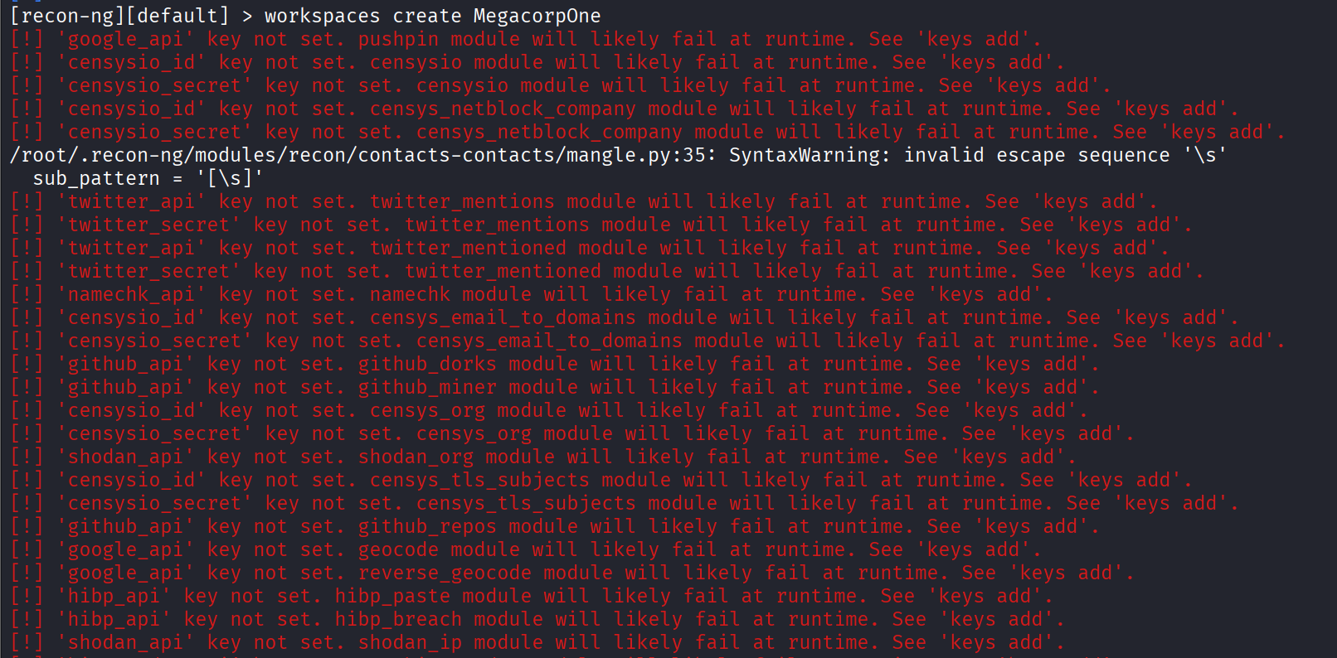Ignore these errors, they are not important.
Ensure that the workspace has been created.
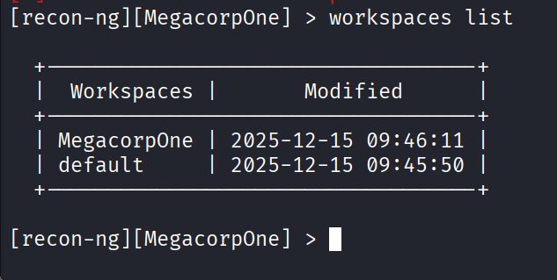

Next, we will add the domains we want to reconnaissance. At this point, it is megacorpone.com
This command “db insert domains” will add the domain to the database. We can verify this using the “show domains” command.
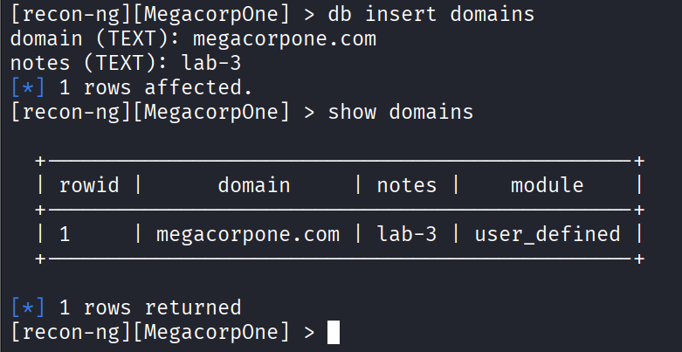
Gather information related to the servers associated with megacorpone.com by loading modules such as brute_hosts, Netcraft, and Bing. Type “modules load brute” and press Enter to see all modules related to brute force. I will use the “recon/domains-hosts/brute_hosts” module to gather server information by using the command “modules load recon/domains-hosts/brute_hosts” and pressing Enter.
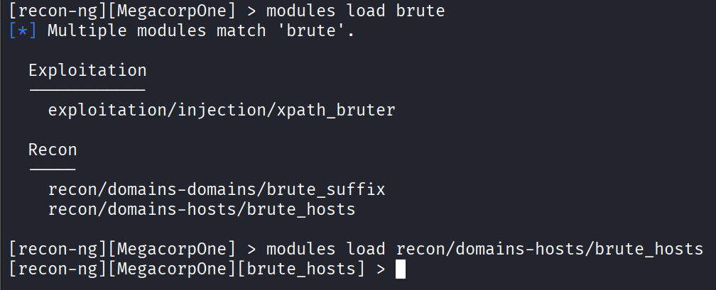
Type “run” and Enter.
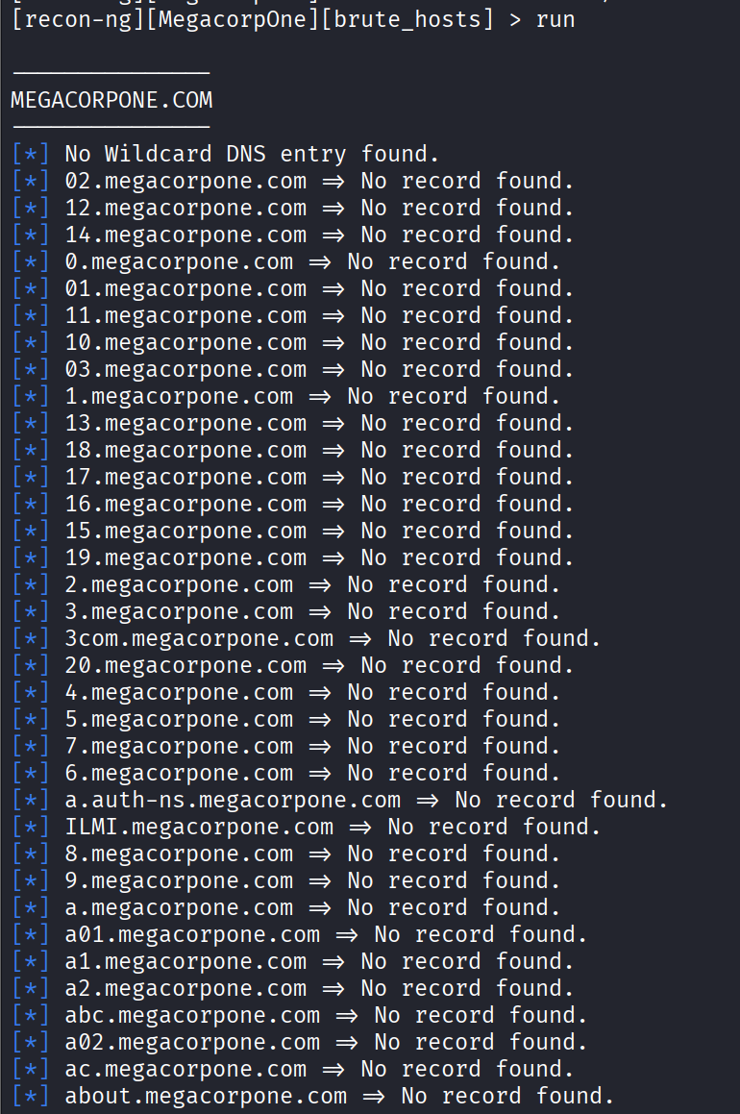

….ETC
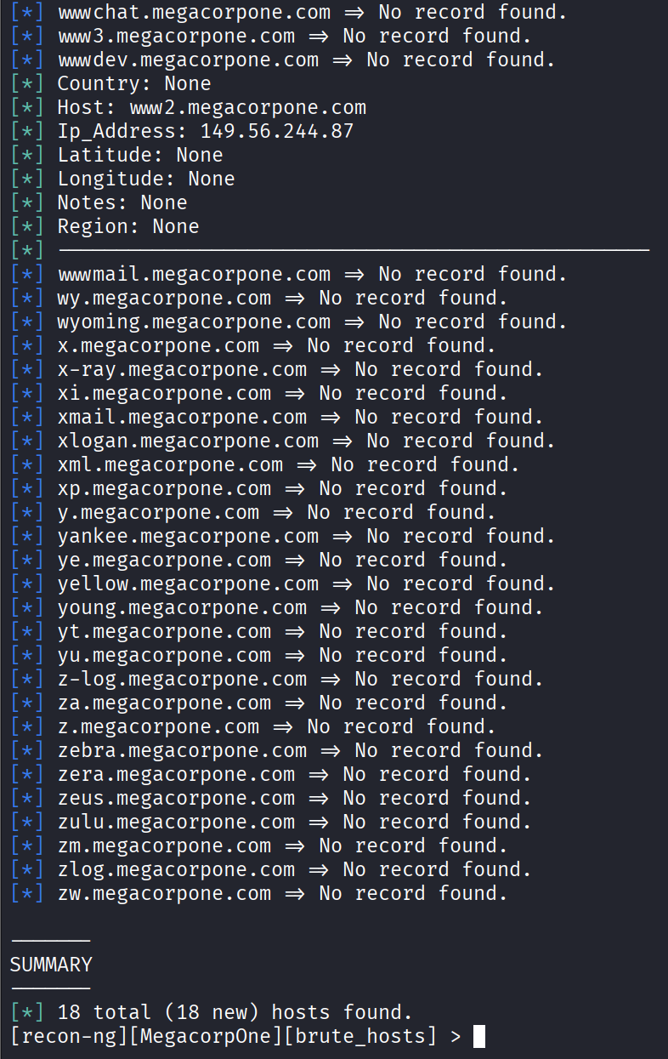
This is a brute-force module, so it has been gathered a lot. In conclusion, we found 18 hosts from this.

Use “show hosts” command to find all the hosts that we have been found.
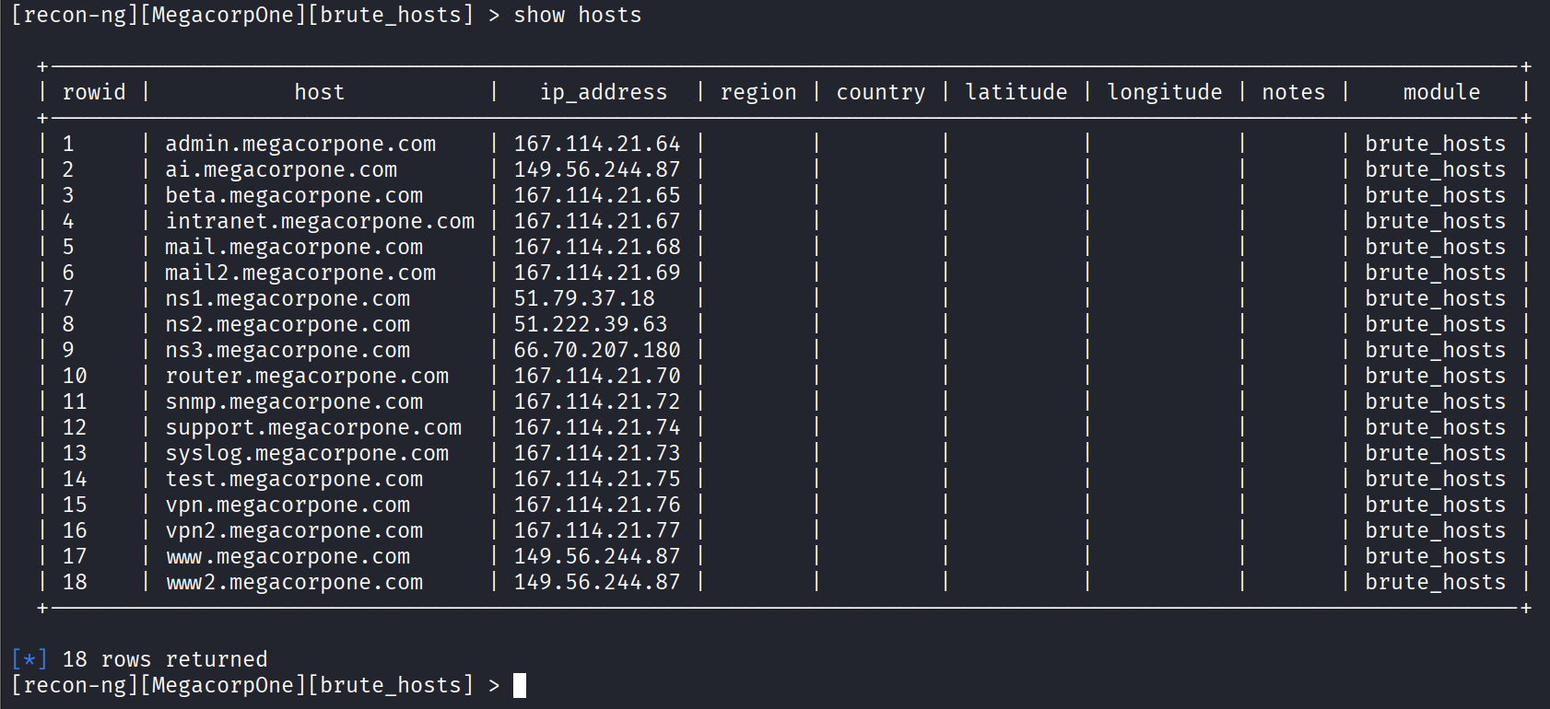
Now lets move to the main part, use the module “recon/hosts-hosts/reverse_resolve” to resolve these IP to its hostname. We will perform a reverse lookup on each IP address to obtain the hostname.
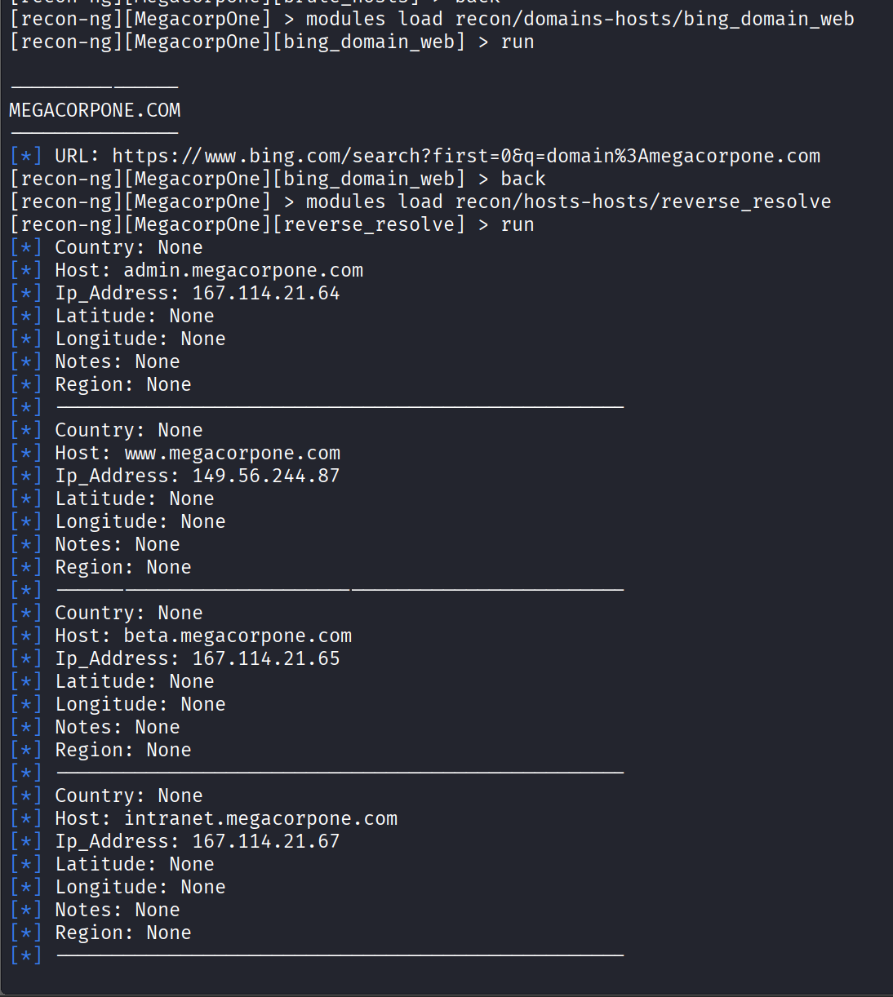
…ETC
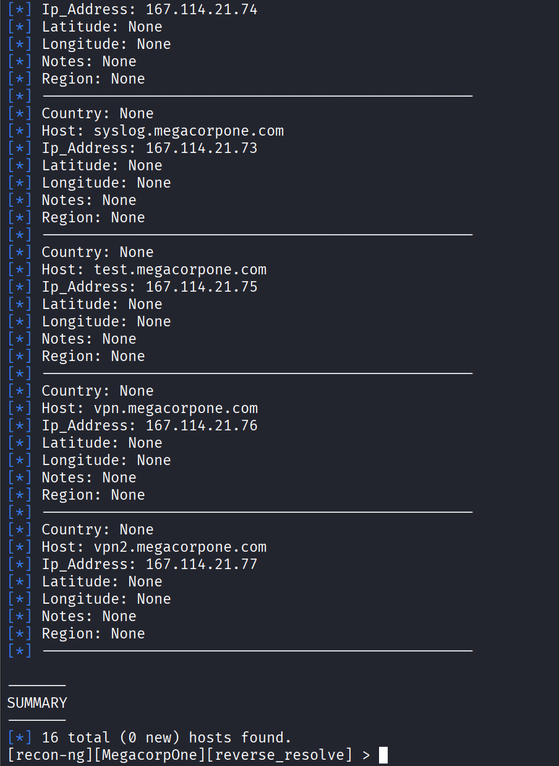
Sadly, no new hosts found, this can mean that megecorpone has its own name server, they do not have a third party.

Creating Reports with the Reporting Module
After obtaining the hosts in the previous step,we can create a report for our result with report module. First, we need to load the reporting module. Type "modules load reporting" and press Enter.
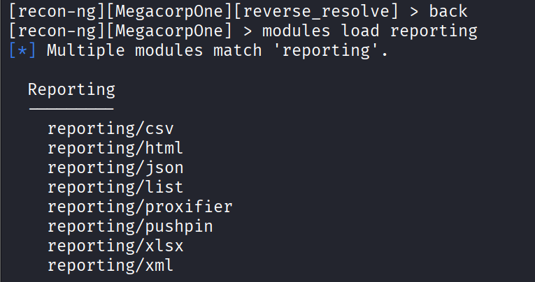
I will choose the html format for this section.
To edit file name: options set FILENAME <path>
Edit creator: options set CREATOR [name]
Edit customer: options set CUSTOMER [name]
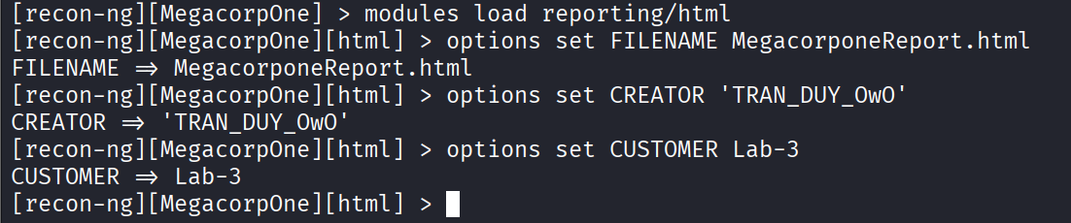
Type “run” to get a report in html format.
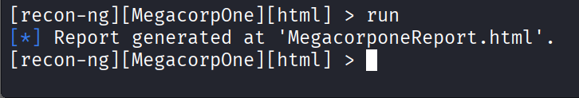
After that we can open the html report in the browser.
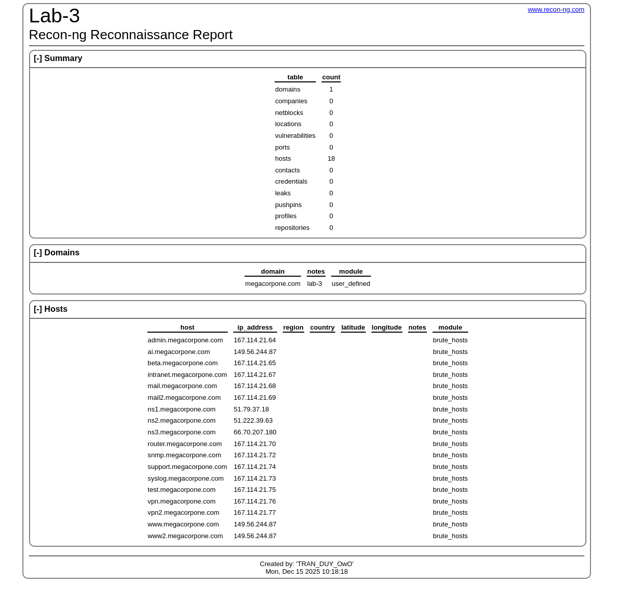
Okay, so this is my report about reconnaissance megacorpone.com, really interesting and educated.

Move to the second part, I will do the reconnaissance for my University at domain uit.edu.vn, the objective is that I will try to gather as much information about UIT as possible.
First, lets create a workspace for this work.
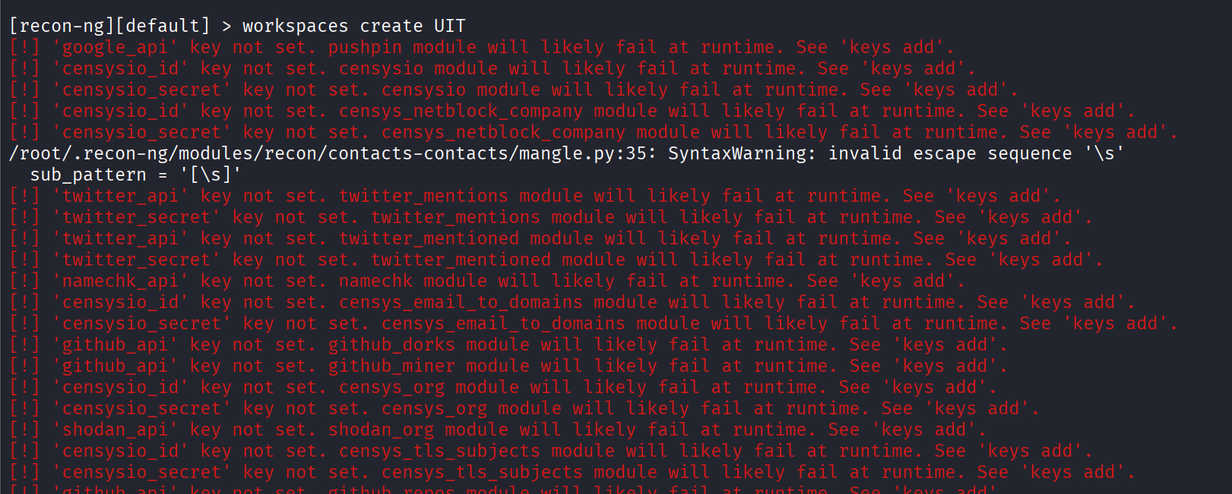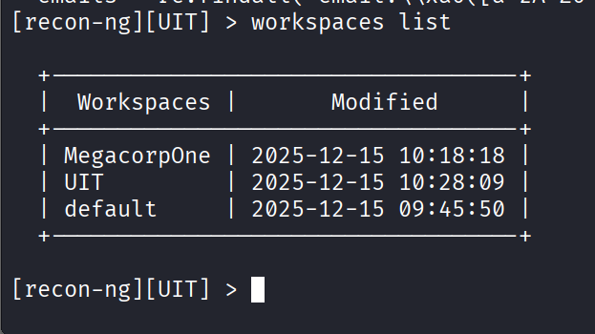
Like the last section, just ignore these errors. Now, we have UIT workspace, lets do some recon.
Adding uit.edu.vn to the database so that we can start recon.
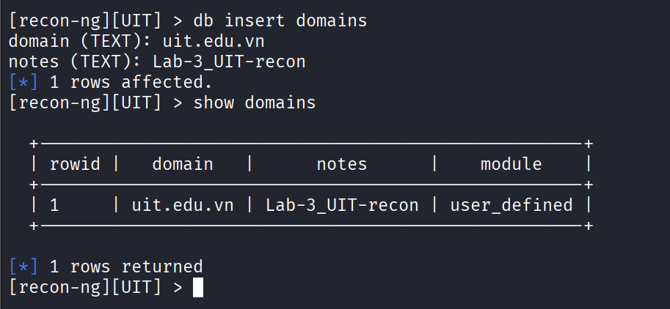
I will use the “recon/domains-hosts/brute_hosts” module to gather associated server related to uit.edu.vn
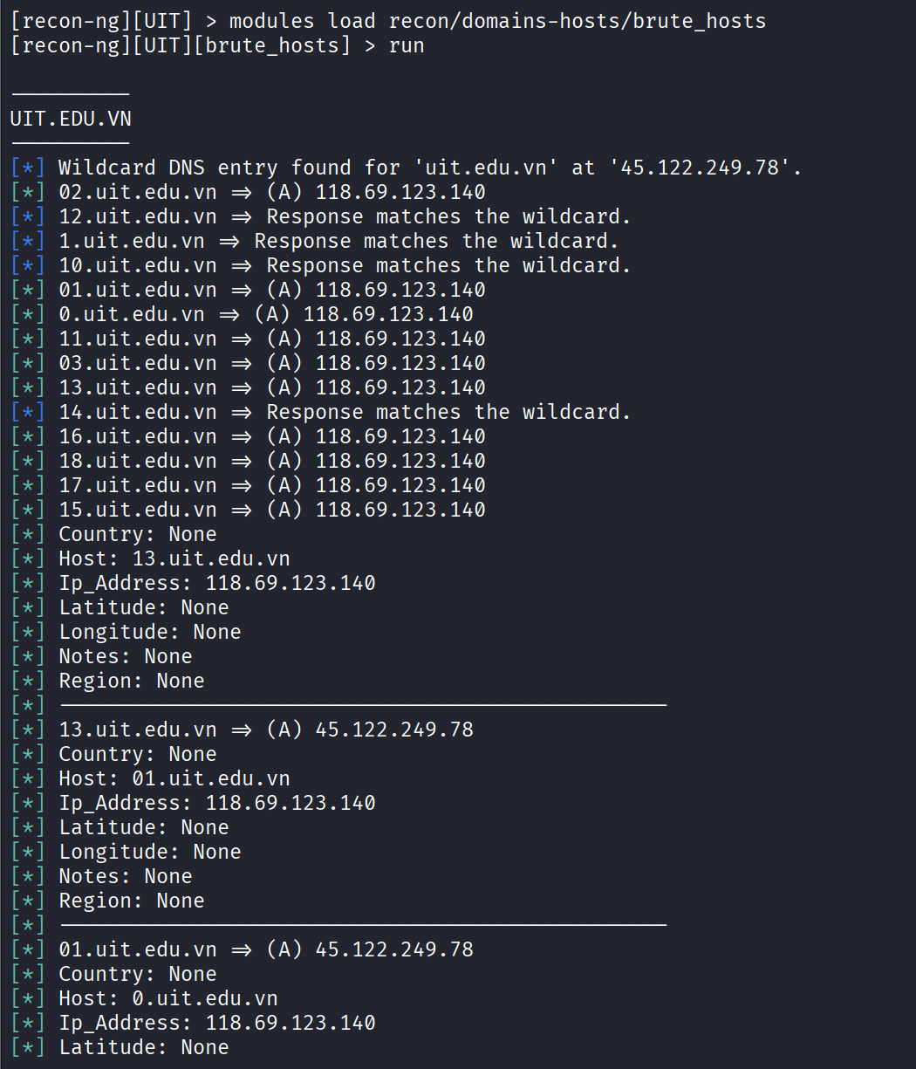
…ETC
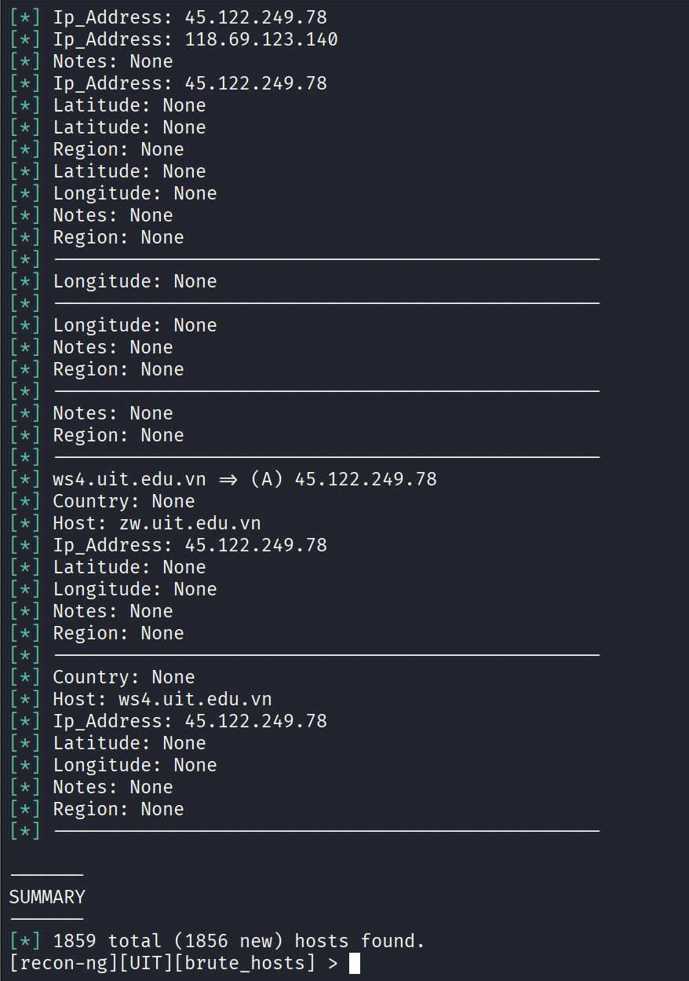
Woah, I cannot imagine, its really 1856 hosts “=))))))”. This is “crazy” “haha”.
Now, lets use “show domains” to see the information about these.
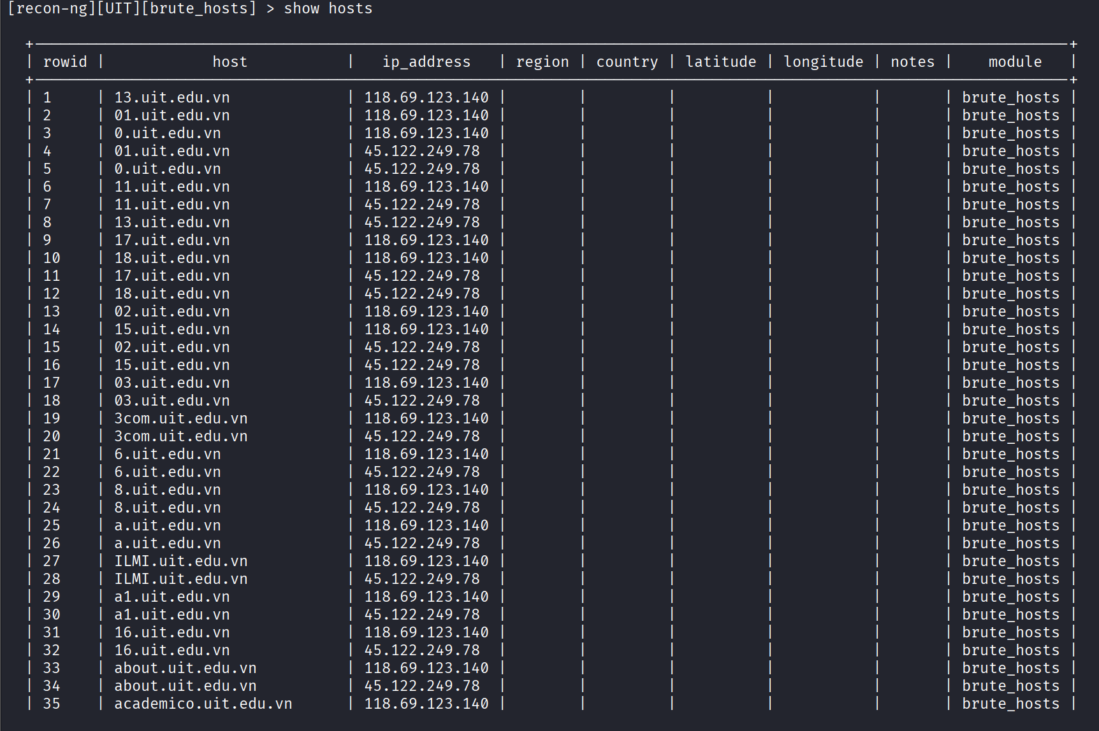
…ETC
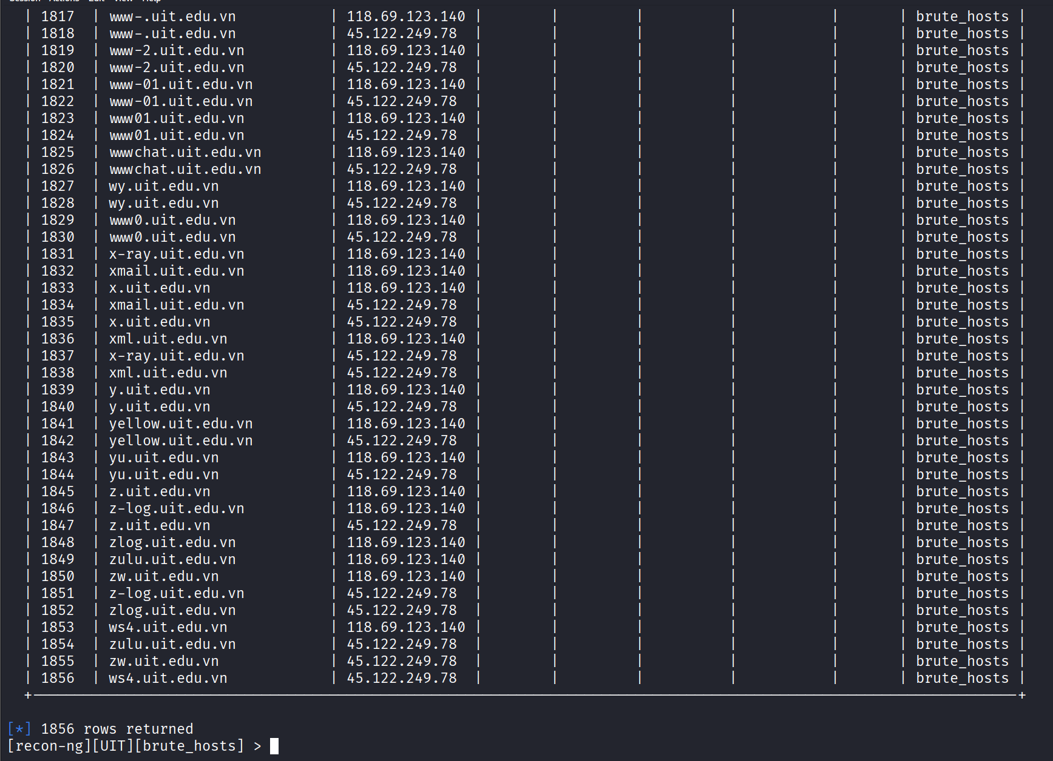
I cannot list all here, cause it’s a lots.

Get hidden hosts from SSL certificate with this module “recon/domains-hosts/certificate_transparency”
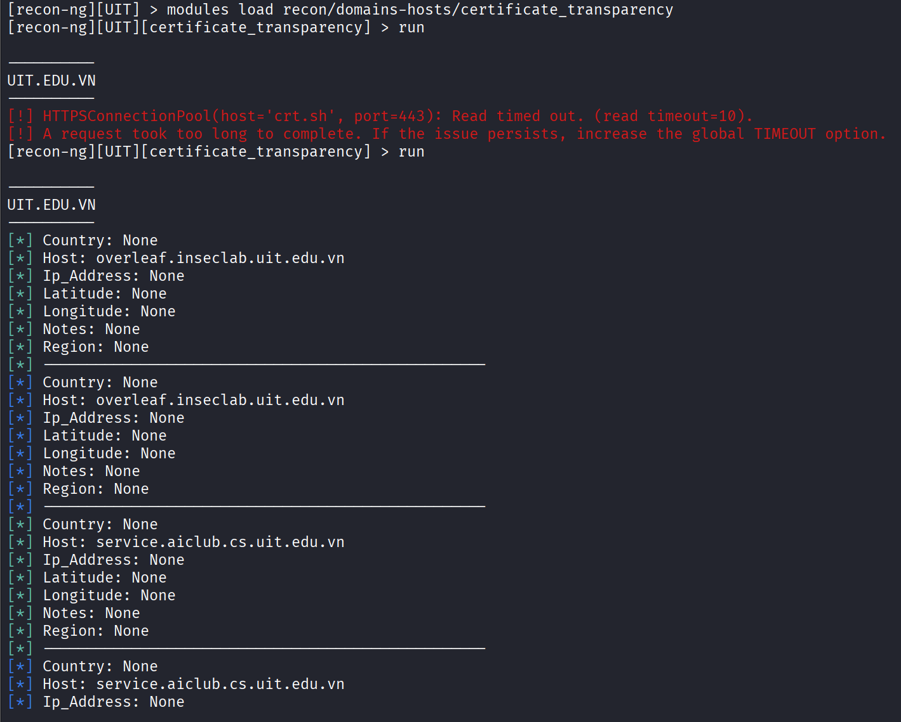
…ETC
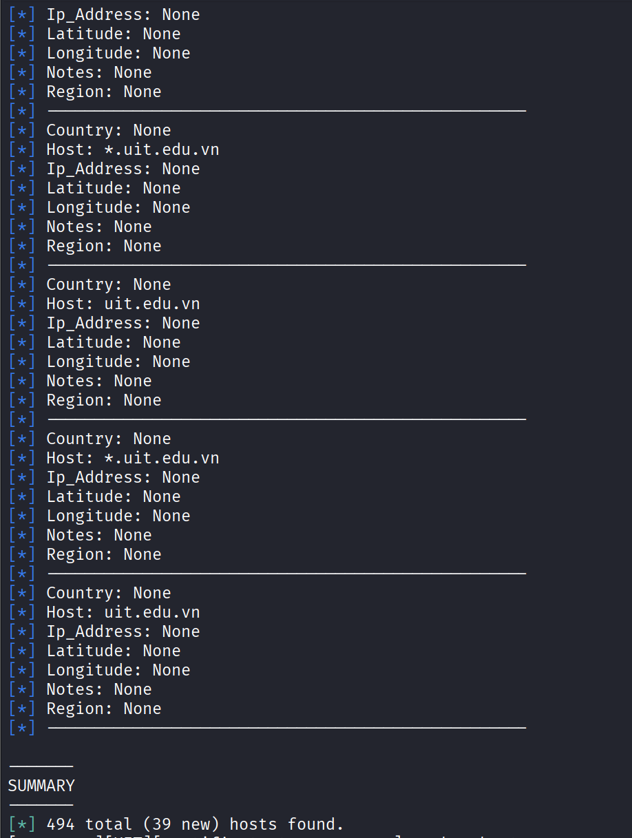

Hehe, found 39 news hidden hosts. Next, I will use “show hosts” to see these new hosts.
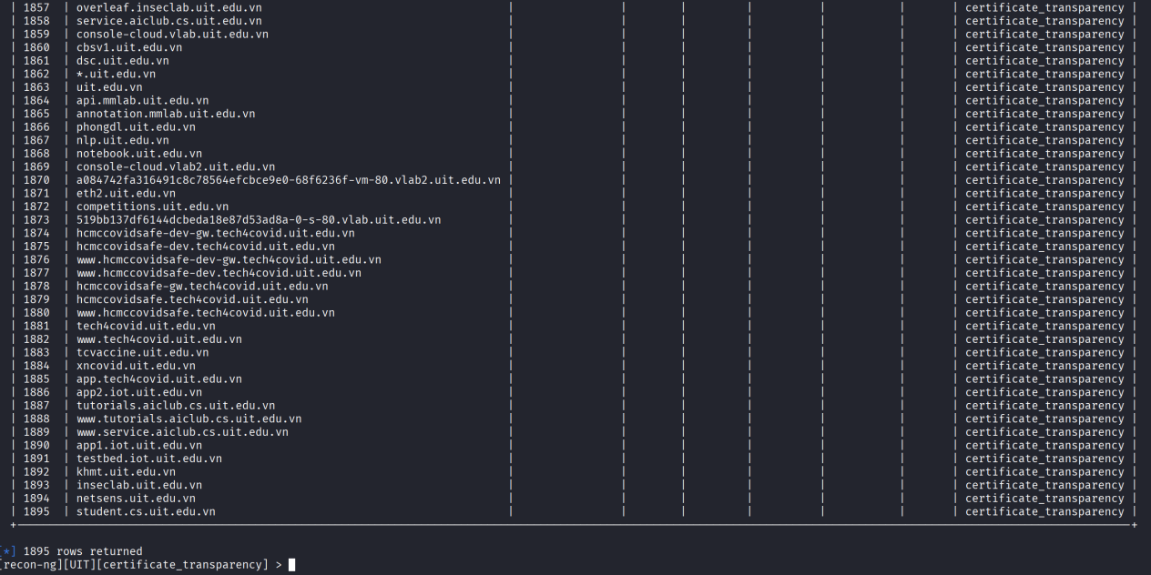
This is all 39 news hosts, some of them are really interesting. I can see the “console-cloud.vlab2.uit.edu.vn “ , I do not know yet, but maybe it nothing important.
Now, lets use “recon/hosts-hosts/reverse_resolve” to map IP to its hostname.
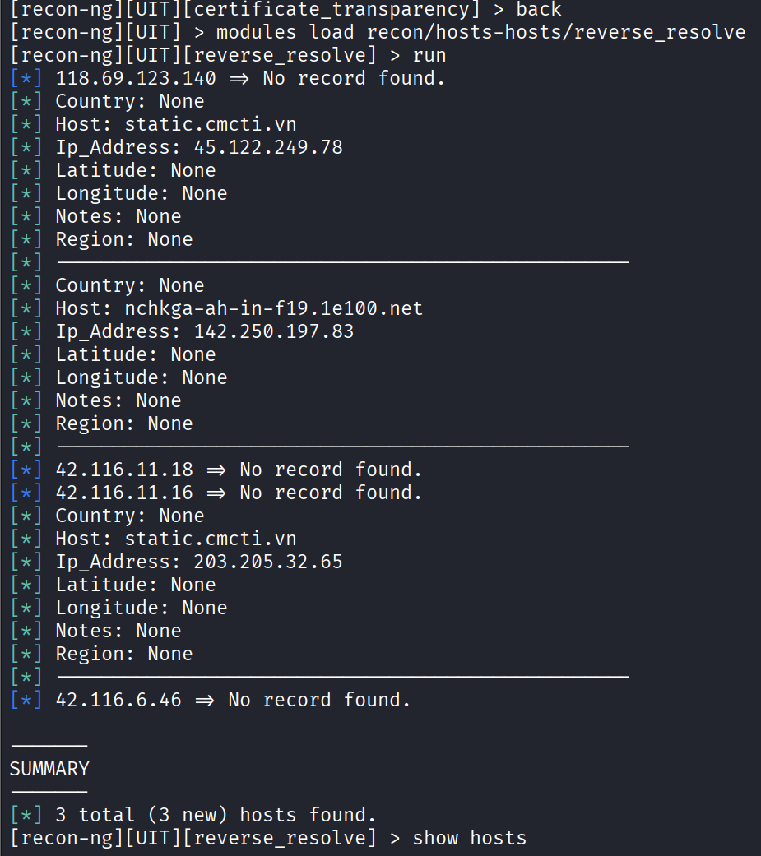
Now, use “show domains” to see new hosts.
After collecting IP addresses associated with hostnames belonging to the uit.edu.vn domain using other recon modules, I continued to use the reverse_resolve module in recon-ng to perform a reverse DNS lookup (PTR record). The purpose of this step was to identify the hostname assigned to each IP address by the infrastructure provider, thereby deducing the management entity or network service provider (ISP/CDN) of these IPs.
The results showed that some IPs had no PTR record (No record found), while others returned hostnames belonging to third-party providers, such as static.cmcti.vn (CMC Telecom) or hostnames belonging to Google's 1e100.net domain. This suggests that UIT's services may be deployed or partially dependent on the infrastructure of external providers, rather than the entire system operating on internal infrastructure.The reverse DNS step helps to clearly distinguish between resources belonging to the UIT and resources belonging to third parties.

Now, lets do a forward DNS, I also need its for some hosts that do not have IP yet. I will use “recon/hosts-hosts/resolve” to resolve IP for hosts.
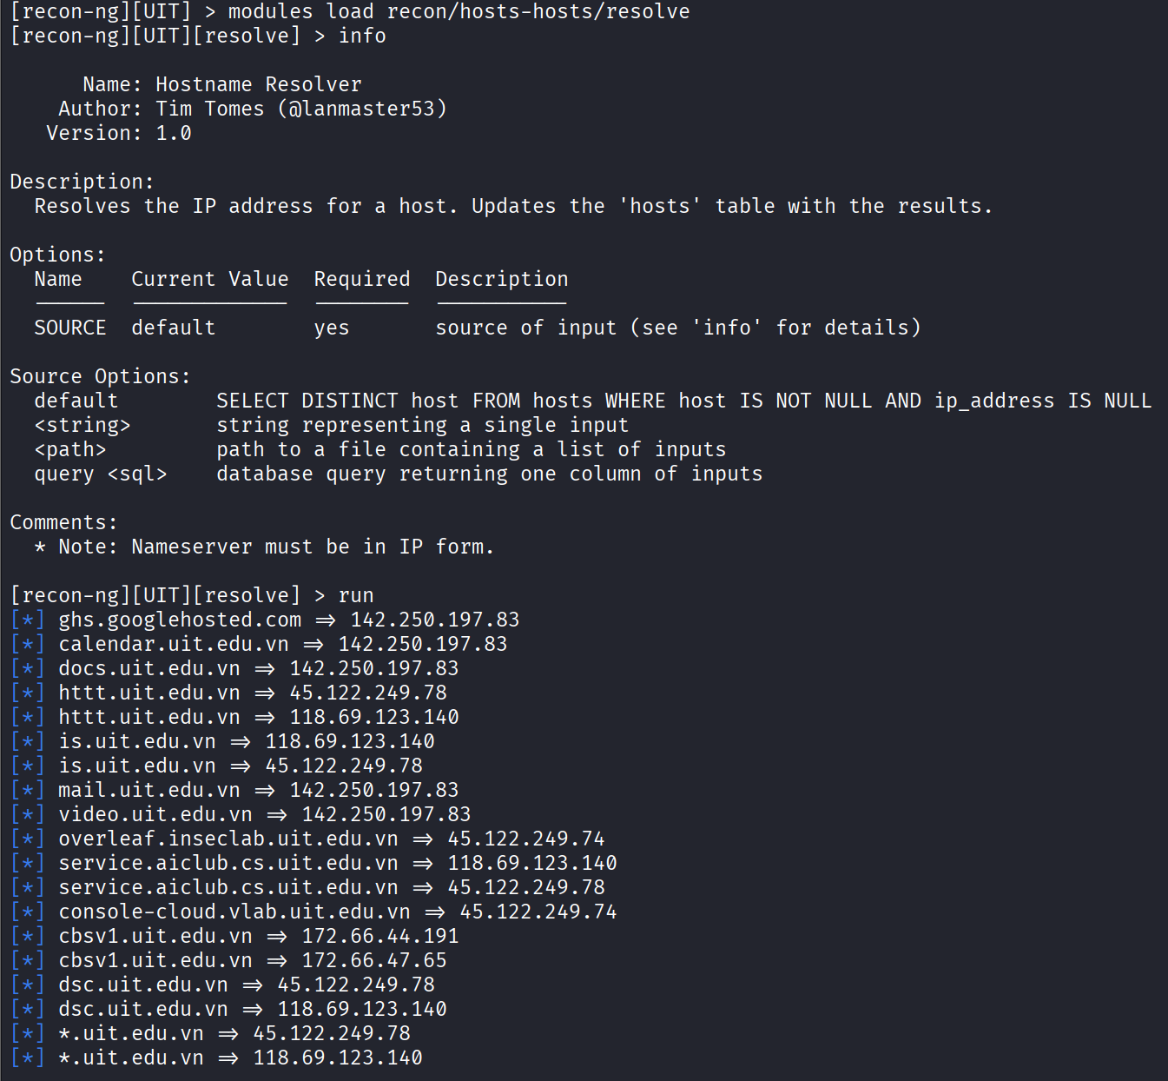
…ETC
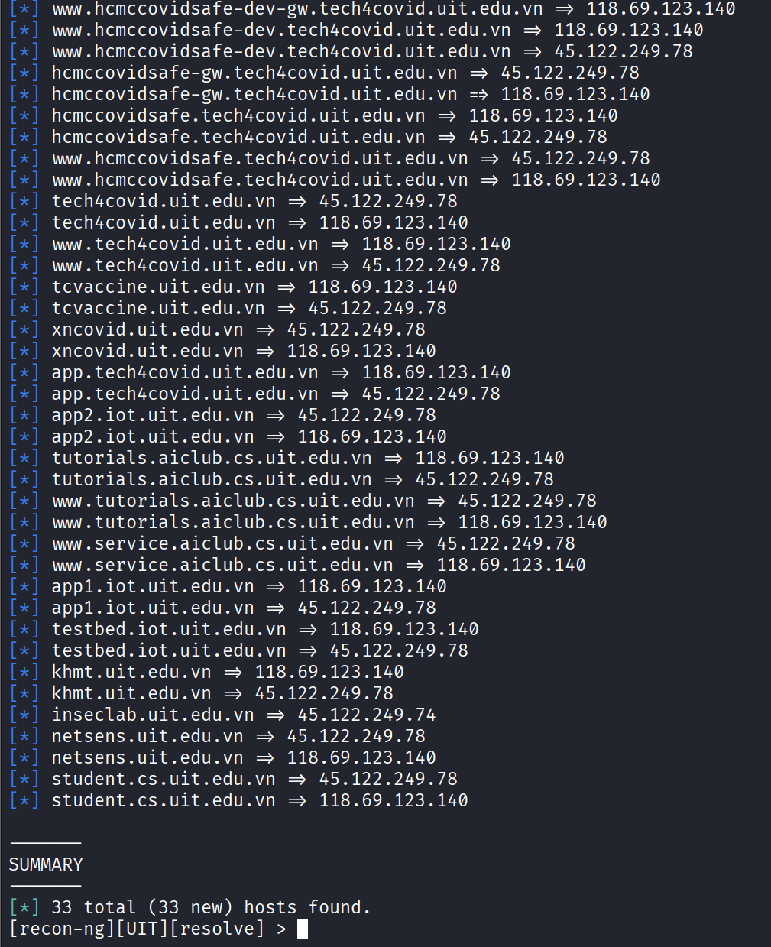
New 33 hosts found with its IP address, we move a next step forward. Now, lets see with “show hosts”.
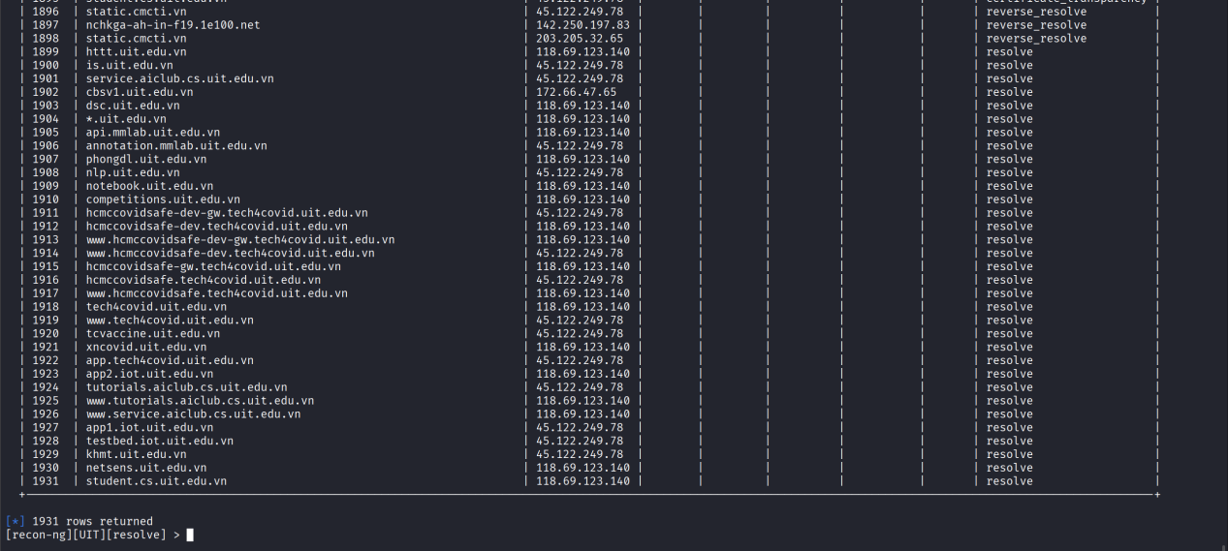
Nice, the subdomain console-cloud.vlab2.uit.edu.vn was successfully resolved to the public IP address 45.122.249.76, indicating that the service is actively reachable from the Internet. The naming convention suggests that this host may be related to a cloud management or laboratory environment, which could potentially expose administrative interfaces if not properly secured.
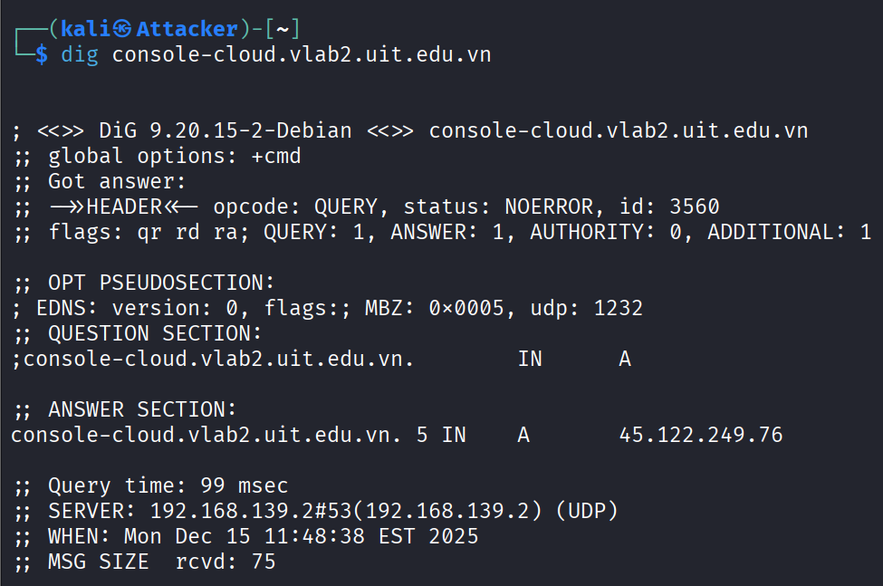
However, the service is not accessible via standard web protocols, which may indicate that the host is protected by firewall rules, restricted to internal access. The low DNS TTL value suggests a dynamically managed infrastructure component.
Now, I will use another modules to scan for new hosts. It is recon/domains-hosts/hackertarget.
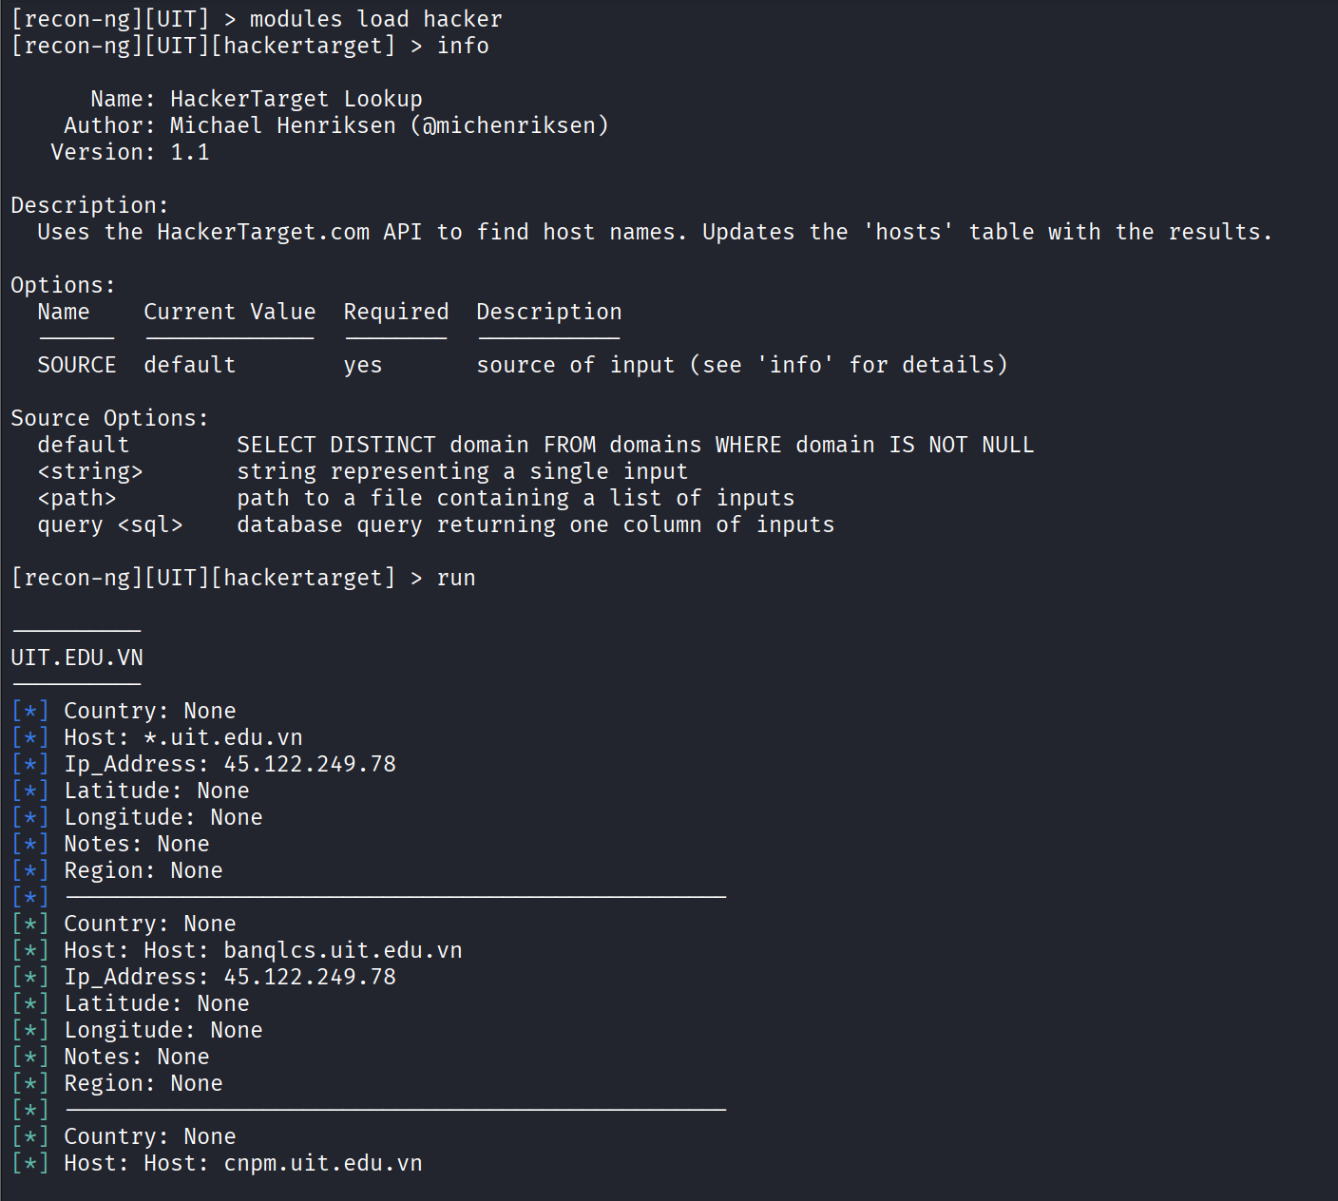
…ETC
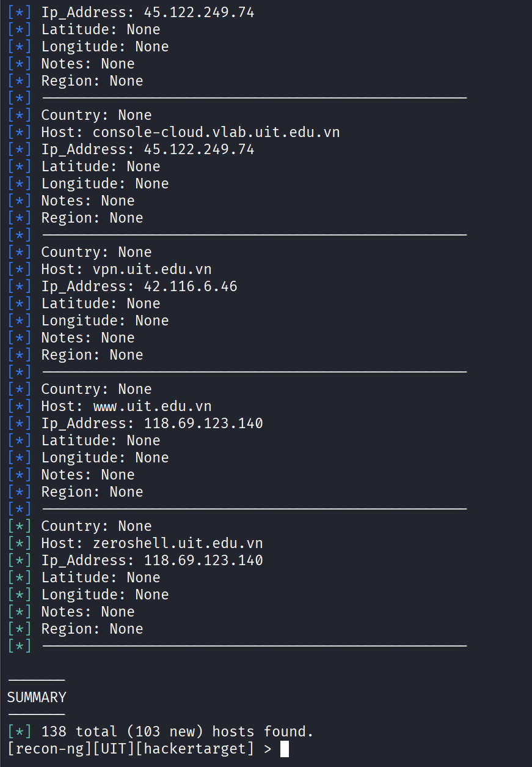
Another new 103 new hosts found, lets use “show hosts”.
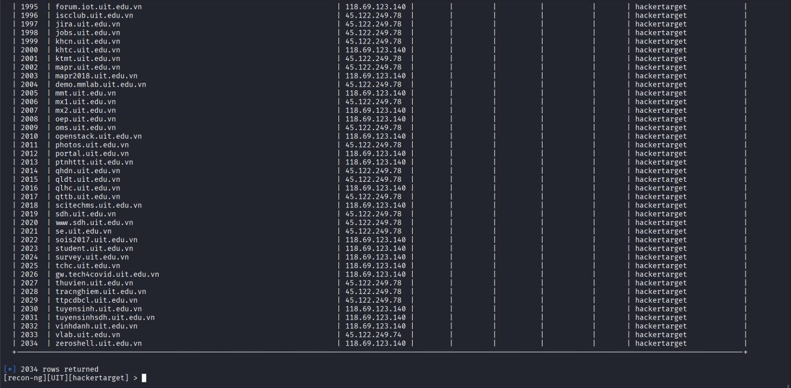
Although some hosts are duplicated, but some are new.
I think I have gathered enough hosts, lets moves to new section. In this section, I will do the ports scan to look for some ports open, using the module “recon/hosts-ports/shodan_ip”.
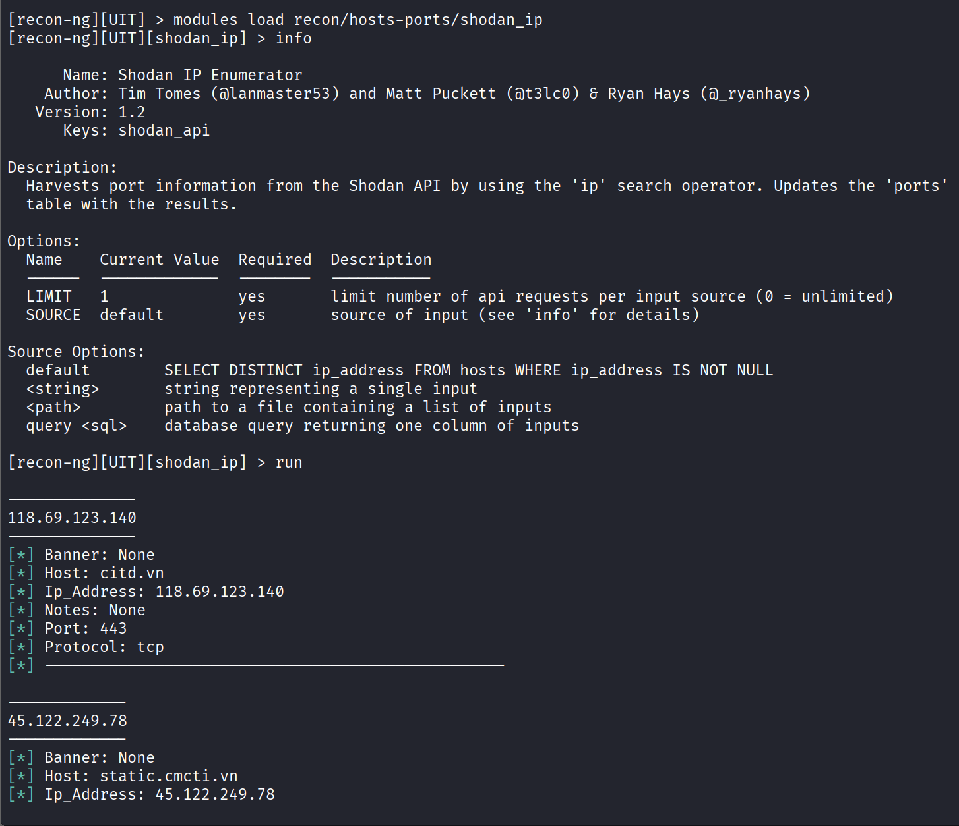
…ETC
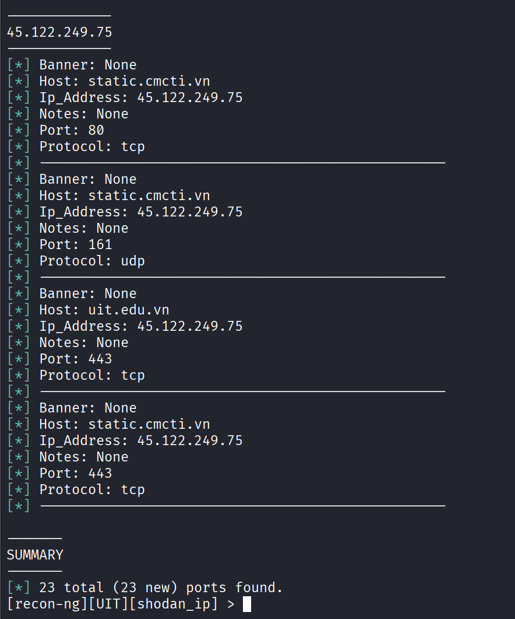
After the shodan successfully scanned, I have found 23 ports open but it just tcp and udp, nothing fun, the console-cloud appear nothing too. “HAIZZZ”. Lets do another recon.
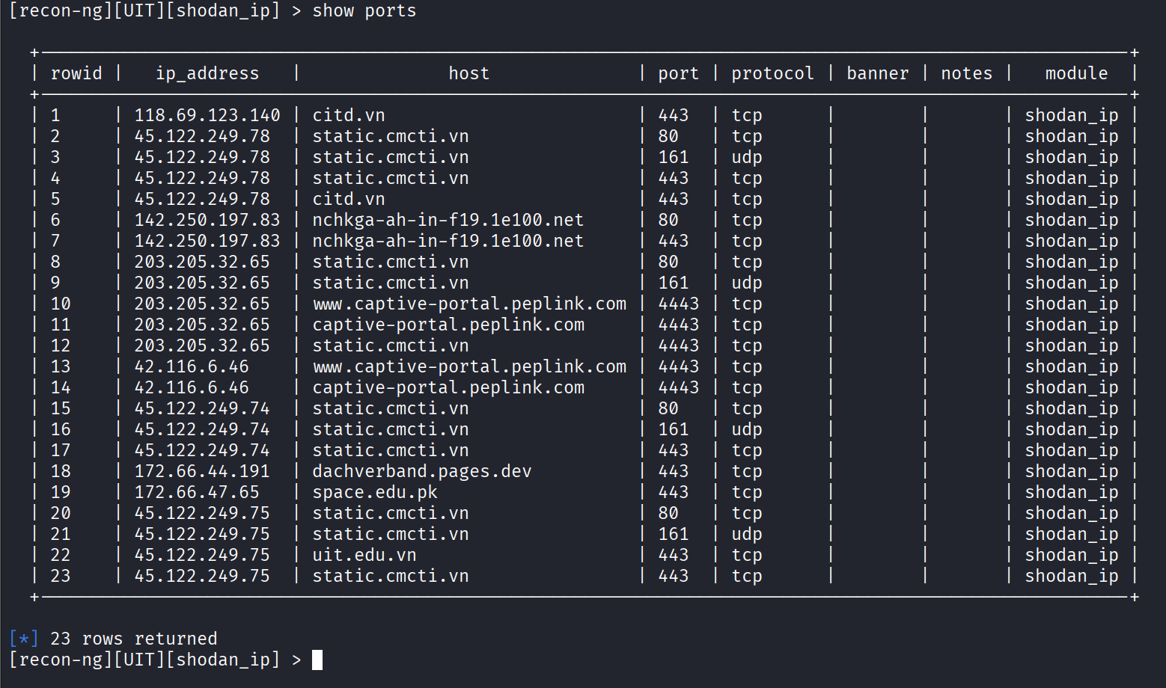
Okay, bad news, there are only 2 hosts-ports modules. I have tried binaryedge but it showed nothing.
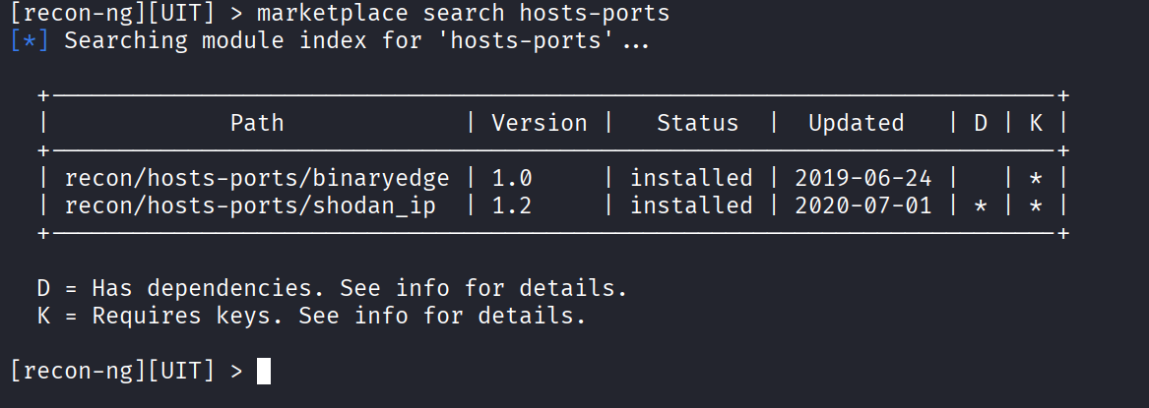

Through the reconnaissance phase, I have identified multiple hosts, IP addresses, and infrastructure components associated with the uit.edu.vn domain, including dependencies on third-party service providers such as Google and CMC Telecom.The reconnaissance results indicate that UIT’s services are distributed across multiple infrastructures, including external providers. This architectural characteristic may introduce additional attack vectors and highlights the importance of proper third-party risk management.
Now, I will use recon-ng to create a report about what I have done. I used th html module for this report. Set some basics options.
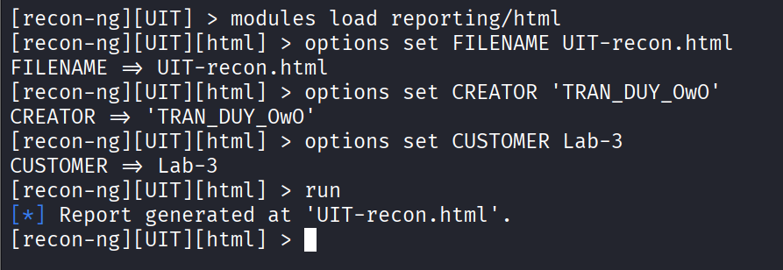
Lets look at the report.
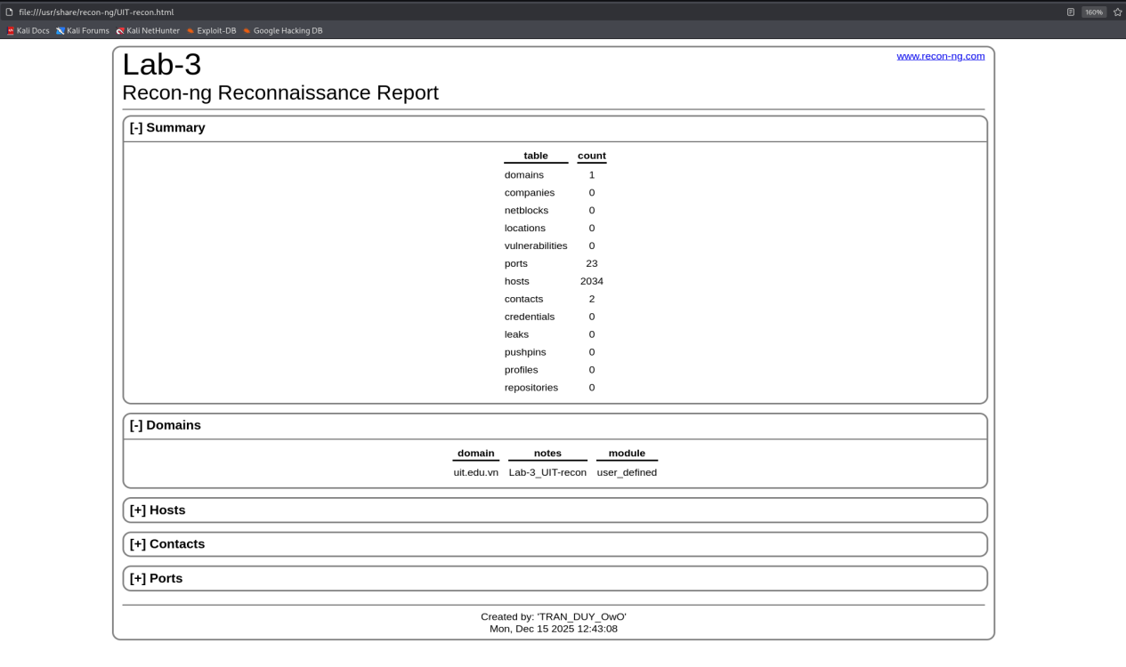
This contains all the hosts and ports that I have found, some of them might be leveraged for attack surface.
Open-Source Code
One place to gather information is from open-source, centralized code hosting sites like GitHub, GitLab, and SourceForge. Access MegaCorp One's GitHub (https://github.com/megacorpone) and use the keyword file:users to search for files containing the keyword "users".
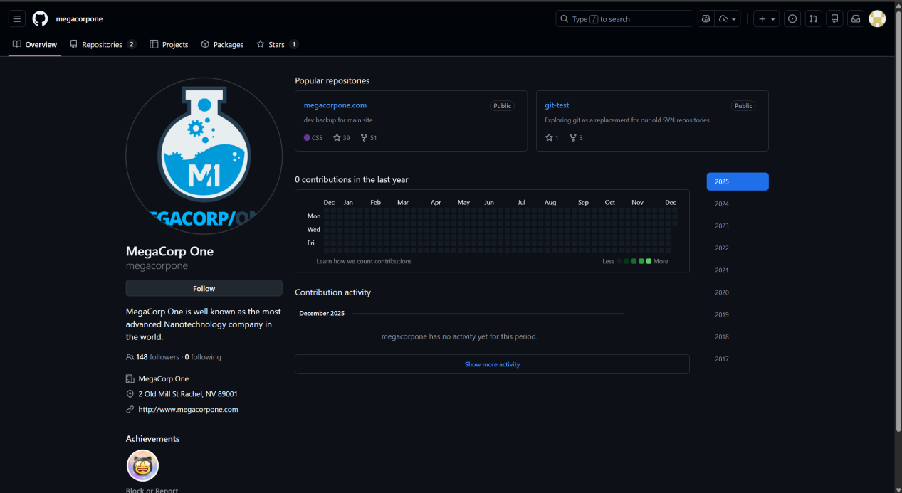
The search results returned only a single file – xampp.users. However, note that XAMPP is a web application development environment, so this can be considered a rather useful finding.
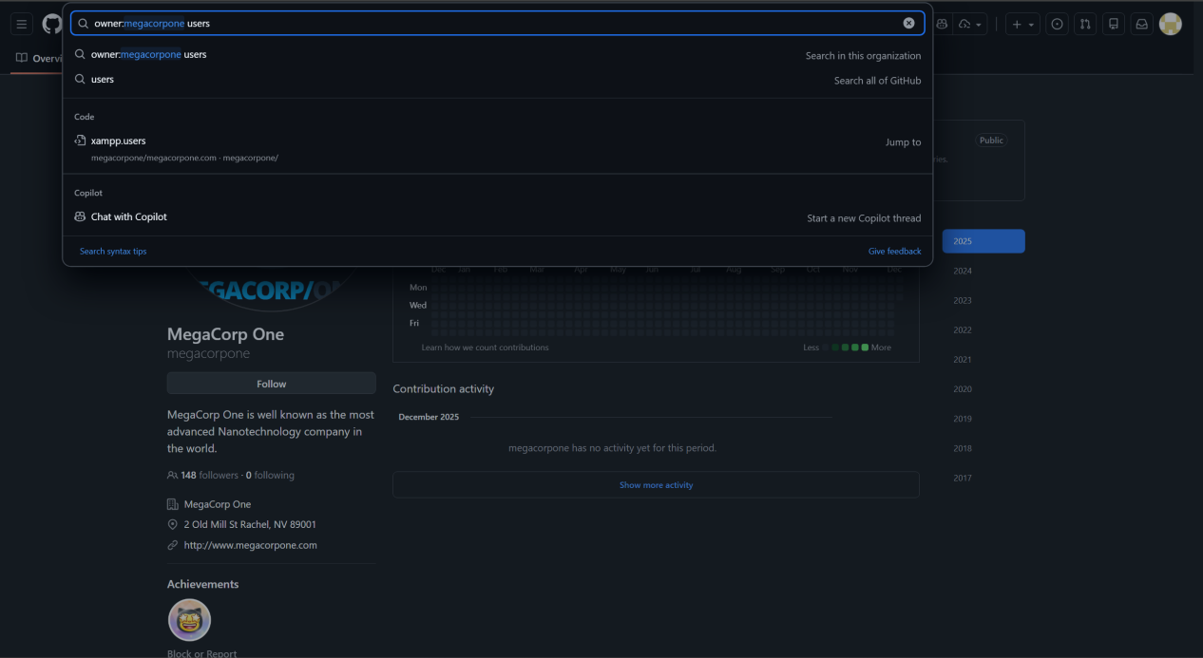

Check the contents of this file. This file contains the username and password (in hash code format), which will be very useful in later stages.

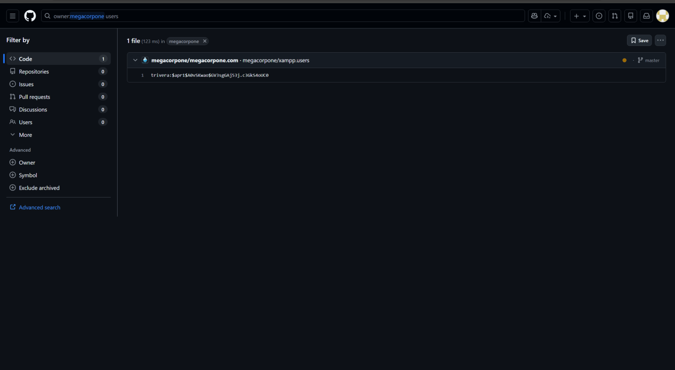
However, this approach will work best for small repositories. For larger repos, we can use additional tools to help automate the search, such as Gitrob (https://github.com/michenriksen/gitrob) or Gitleaks (https://github.com/zricethezav/gitleaks).

Task 6: Use either Gitrob or Gitleaks to search for sensitive information leaked from member universities within the Vietnam National University.
Let’s get started with Gitleaks first, cause its name make me interested.
Install Gitleaks in kali linus with command “sudo apt install gitleaks”.
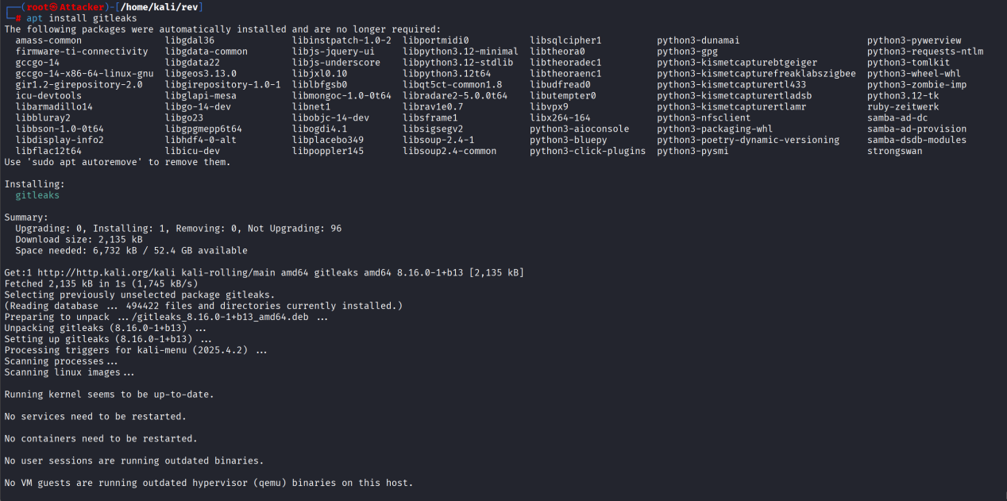

Proactive information gathering
DNS Enumeration
The Domain Name System (DNS) is one of the most important systems on the Internet and is a distributed database responsible for converting domain names into IP addresses.
+ Interacting with DNS Servers
Each domain name can use different types of DNS records. Some of the most common DNS records include:
- NS – Nameserver record containing the name of the authoritative server that stores DNS records for a particular domain name.
- A – Also known as the host record, used to resolve a host to a 32-bit IPv4 address. Used to point a website name like www.domain.com to a server hosting that website.
- MX – Mail Exchange record containing the names of the servers responsible for handling email for the domain name. A domain name can contain multiple MX records:
- PTR – Pointer records used in reverse lookup zones and used to find hostnames corresponding to the desired IP address.
- CNAME – Canonical Name records used to create aliases for host records.
- TXT – Text records that can contain any data and can be used for various purposes, such as domain name ownership certification.
Because so much information is contained within DNS, it is often a target during the proactive data collection phase.
Use the “host” command to find the IP address of www.megacorpone.com
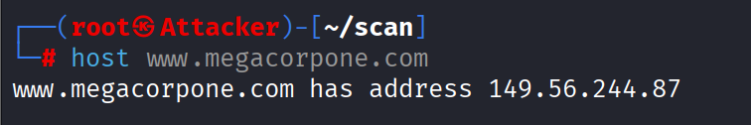
By default, the “host” command will search for A records, but we can request other records, such as TXT or MX. Use the “-t” option to specify the type of record to search for.
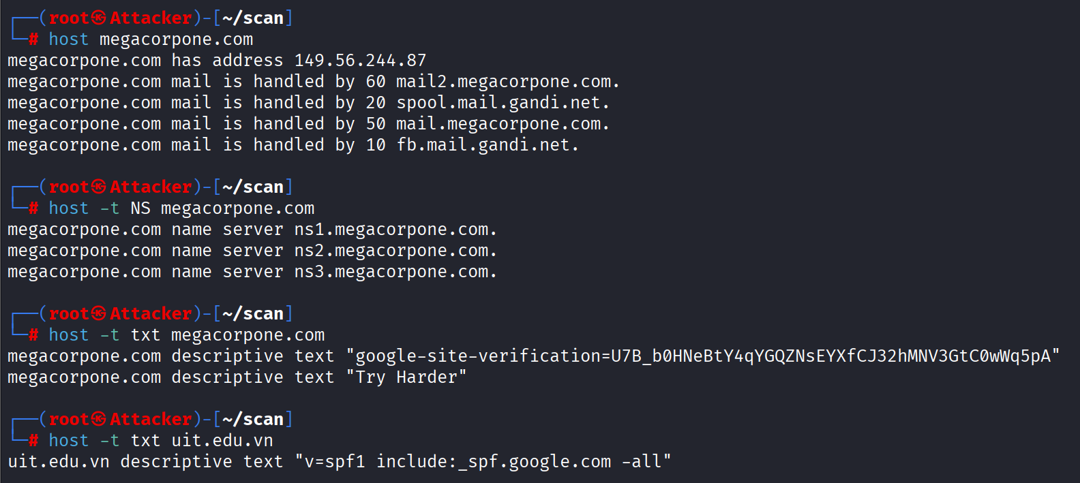

Task 7:
In addition to common DNS records such as A, NS, MX, CNAME, PTR, and TXT, DNS supports various other record types including AAAA for IPv6 addressing, SOA for zone administration, SRV and NAPTR for service discovery, and CAA for certificate authority control. Security-related records such as DNSKEY, DS, and RRSIG are used in DNSSEC to ensure the authenticity and integrity of DNS data.
- AAAA – Similar to the A record, but maps a hostname to a 128-bit IPv6 address instead of IPv4.
- SOA (Start of Authority) – Contains administrative information about the DNS zone, including the primary nameserver, zone administrator email, serial number, refresh, retry, and expiration values.
- SRV (Service Record) – Specifies the location (hostname and port number) of servers for specific services, commonly used for services such as VoIP, LDAP, and Microsoft Active Directory.
- CAA (Certification Authority Authorization) – Defines which Certificate Authorities (CAs) are allowed to issue SSL/TLS certificates for a domain, helping prevent unauthorized certificate issuance.
- NAPTR (Name Authority Pointer) – Used for more complex service discovery and often in combination with SRV records, particularly in SIP and telecommunication systems.
- DNSKEY – Stores public keys used in DNSSEC to verify the authenticity and integrity of DNS data.
- DS (Delegation Signer) – Used in DNSSEC to link a child zone to its parent zone and establish a chain of trust.
- RRSIG – Contains digital signatures for DNSSEC-signed records, ensuring data integrity and authenticity.
- LOC – Specifies the geographical location (latitude, longitude, altitude) of a domain or host.
- HINFO – Provides information about the host’s hardware and operating system (rarely used today due to security concerns).
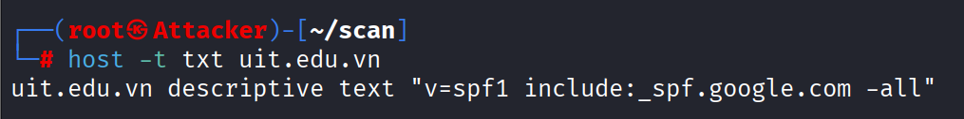
A DNS TXT record query revealed that the domain uit.edu.vn has an SPF record configured as v=spf1 include:_spf.google.com -all. This configuration indicates that the organization relies on Google’s mail infrastructure for sending emails and strictly rejects email messages originating from unauthorized mail servers. Such a configuration helps prevent email spoofing and phishing attacks, demonstrating a strong email security posture.
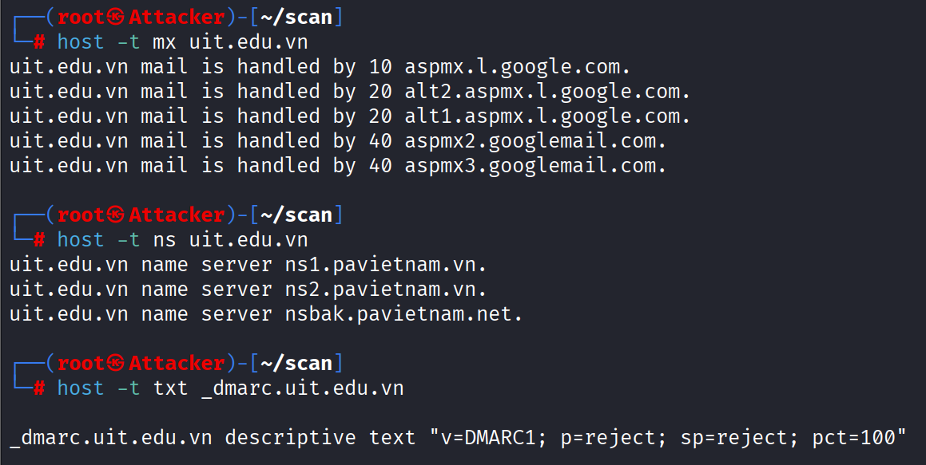
DNS analysis of the domain uit.edu.vn revealed that its email infrastructure is fully managed by Google. The MX records point to multiple Google mail servers with prioritized redundancy, ensuring high availability. Additionally, the domain enforces a strict email authentication policy using SPF and DMARC. The SPF record authorizes only Google mail servers to send emails on behalf of the domain, while the DMARC policy is configured with p=reject and sp=reject, applying to 100% of messages. This configuration effectively mitigates email spoofing and phishing attacks, demonstrating a strong email security posture.

+ Automation Lookups
Now that we've gathered some information from the domain megacorpone.com, we can continue using DNS queries to search for hostnames and IP addresses that belong to the same domain.
Use the “host” command again for the www.megacorpone.com server.
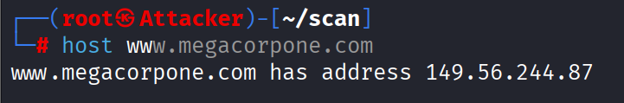
Now, check if megacorpone.com has a server with the hostname “noexist”. Observe the differences between the returned results.
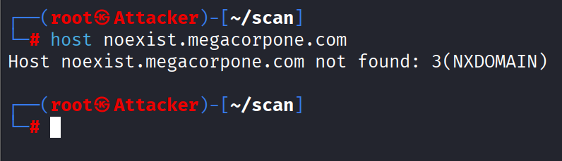
In above figure, we queried a valid hostname and received the corresponding IP address. Conversely, in this figure, the error message "host not found" indicates that the DNS record does not exist for this hostname. Now that we understand how to find valid hostnames, we can automate this process.

Task 8: Use the `host` command for hostnames that do not exist in the “uit.edu.vn” domain:
(idontexist, noexist, baithuchanhso2).
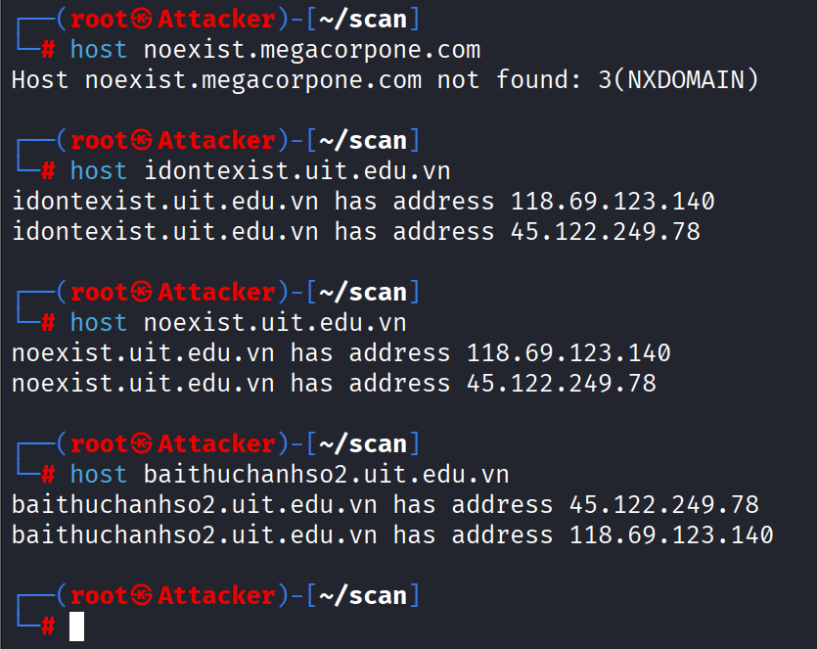
During DNS reconnaissance, multiple randomly generated and non-existent hostnames under the domain uit.edu.vn (e.g., idontexist.uit.edu.vn, noexist.uit.edu.vn) were queried using standard DNS tools. Instead of returning NXDOMAIN, the DNS server consistently resolved these hostnames to the same set of public IP addresses (118.69.123.140 and 45.122.249.78). This behavior is a strong indicator that the domain is configured with wildcard DNS records, causing all undefined subdomains to resolve to predefined IP addresses.
In contrast, performing the same tests against a domain without wildcard DNS configuration, such as megacorpone.com, resulted in NXDOMAIN responses for non-existent hostnames. This comparison clearly demonstrates the difference between standard DNS behavior and wildcard DNS configuration, confirming that the observed behavior in uit.edu.vn is not accidental but intentionally configured.
From a security perspective, wildcard DNS can simplify domain management and provide a consistent user experience; however, it also introduces potential security concerns. Specifically, wildcard DNS can significantly hinder accurate subdomain enumeration, leading to false positives during reconnaissance. Moreover, it may unintentionally expose internal infrastructure by directing arbitrary hostnames to active servers, increasing the attack surface and potentially allowing attackers to probe backend services through unexpected entry points.
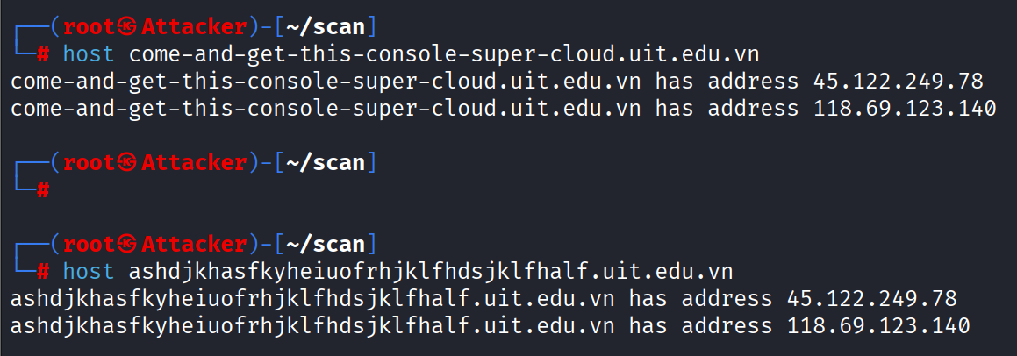
This one can definitely confirm that UIT use wildcard DNS, I have randomly input meaningless hostnames but it still response me with IP address for these hostnames.
Although the domain uit.edu.vn resolves to multiple IP addresses belonging to different Internet service providers (FPT and CMC), this does not imply that the website belongs to those providers. DNS resolution only maps a domain name to IP addresses. The actual website is determined at the HTTP/HTTPS layer using the Host header (and SNI in the case of HTTPS), allowing multiple domains to be hosted on the same IP address through virtual hosting.
For example, when I know UIT uses wildcard DNS, then actually its not bad at all, I can know which domain is real and which is fake base on the result I get. If I get only one IP, it means that this domain is real and it is host on that IP. This can maybe increase the attack surface if attacker know this trick.
The entire passive recon and this one scan do increase my knowledge about UIT DNS architecture.
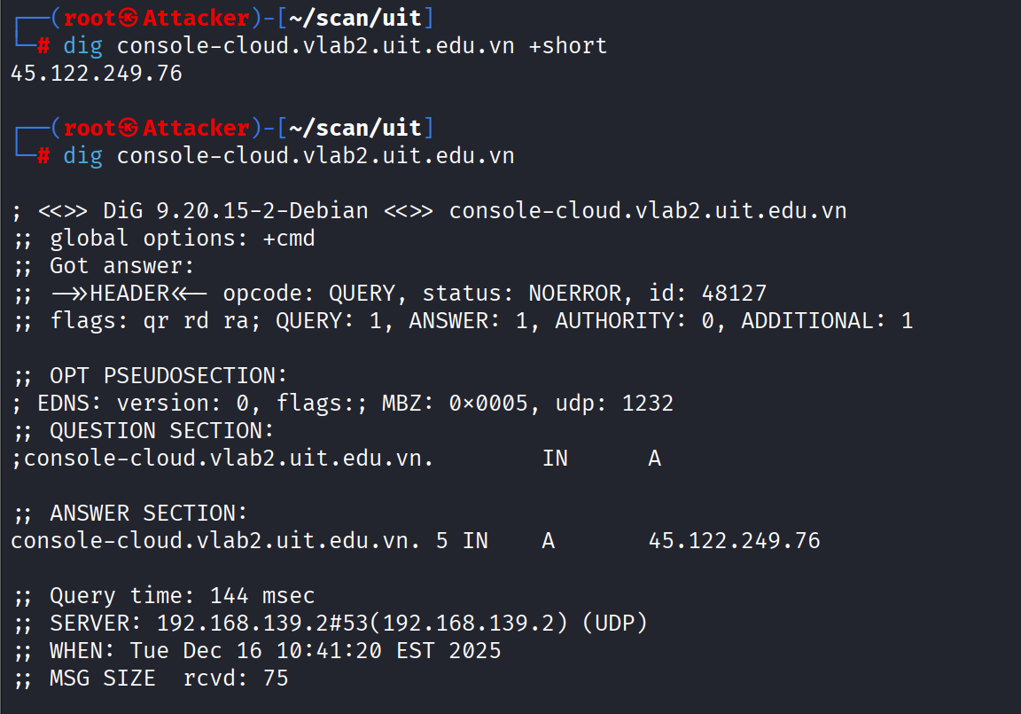
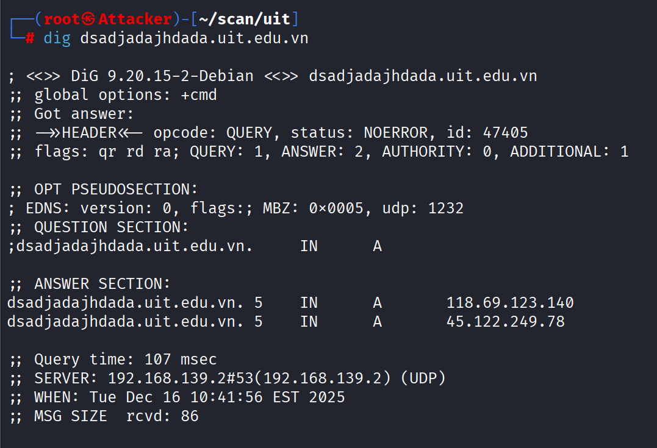
The DNS architecture of uit.edu.vn demonstrates a centrally managed and resilient design. The domain is delegated to authoritative name servers operated by PA Vietnam (ns1.pavietnam.vn, ns2.pavietnam.vn, nsbak.pavietnam.net), while DNS resolution for the main domain and its subdomains returns multiple public IP addresses belonging to different Internet service providers, notably FPT and CMC. This multi-IP configuration indicates the use of multi-ISP hosting for redundancy and availability. Additionally, wildcard DNS is enabled on the domain, causing non-existent subdomains to resolve to predefined IP addresses. While this simplifies DNS management and ensures consistent responses, it also introduces challenges during reconnaissance by generating false positives in automated subdomain enumeration. Email-related DNS records, including MX, SPF, and DMARC, are properly configured and point to Google Mail servers, reflecting a separation between web hosting and email infrastructure and an emphasis on protection against email spoofing. Overall, the DNS architecture reflects a design prioritizing availability and centralized control, with security trade-offs that must be considered during external reconnaissance and attack surface analysis.

+Forward Lookup Brute Force
Brute force is a technique for searching for valid information, including directories on a web server,
username and password combinations, or in this case, valid DNS records. By using a list of common hostnames, we can use it to guess DNS records and check the returned results for valid hostnames.
First, create a list of common hostnames.
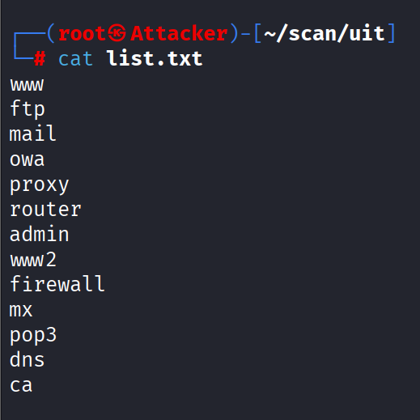
Use a Bash script to resolve each hostname in the list.
“for ip in $(cat list.txt); do host $ip.megacorpone.com; done;”
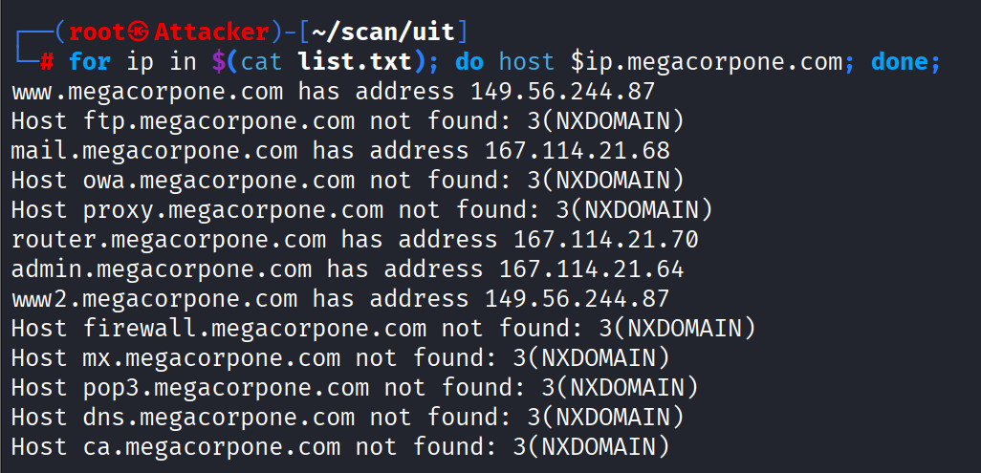

Task 9: Use other common wordlists (rockyou, seclists) to search for other valid hostnames for megacorpone.com
I choose Seclists because it has DNS common hostnames, rockyou is just a password list so it means nothing here. Then I chose “subdomain-topmillion-5000.txt”, this is the most common 5000 hostnames, also I chose it cause scan this consume a lot of time, so I think 5000 is enough for this task.
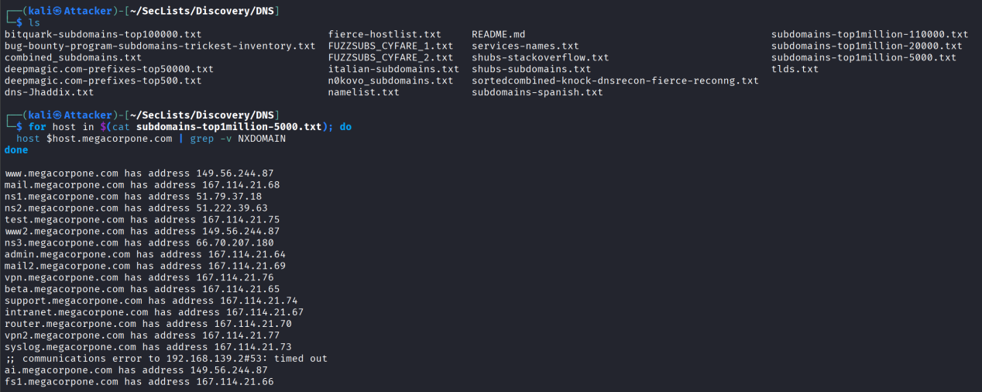
51.222.39.63, 51.79.37.18, 66.70.207.180, 149.56.244.87, 167.114.21.64, 167.114.21.65, 167.114.21.66, 167.114.21.67, 167.114.21.68, 167.114.21.69, 167.114.21.70, 167.114.21.73, 167.114.21.74, 167.114.21.75, 167.114.21.76, 167.114.21.77

+ Reverse Lookup Brute Force
In addition to the IP ranges previously identified for megacorpone.com, several additional public IP addresses associated with MegaCorp One infrastructure were discovered, including:
51.222.39.63, 51.79.37.18, 66.70.207.180, 149.56.244.87, and the IP range 167.114.21.64–167.114.21.77.
If the administrators of MegaCorp One have properly configured PTR (reverse DNS) records, it is possible to perform reverse DNS enumeration to identify hostnames associated with these IP addresses. Reverse DNS queries map IP addresses back to domain names, potentially revealing internal or externally accessible services belonging to the organization.
To enumerate PTR records, each IP address in the identified range was queried using DNS reverse lookups. Invalid or non-existent hostnames were filtered out using the grep -v option to exclude irrelevant results.
This technique allows the identification of hostnames that may not be discoverable through standard forward DNS enumeration, thereby providing additional insight into the organization’s network infrastructure.
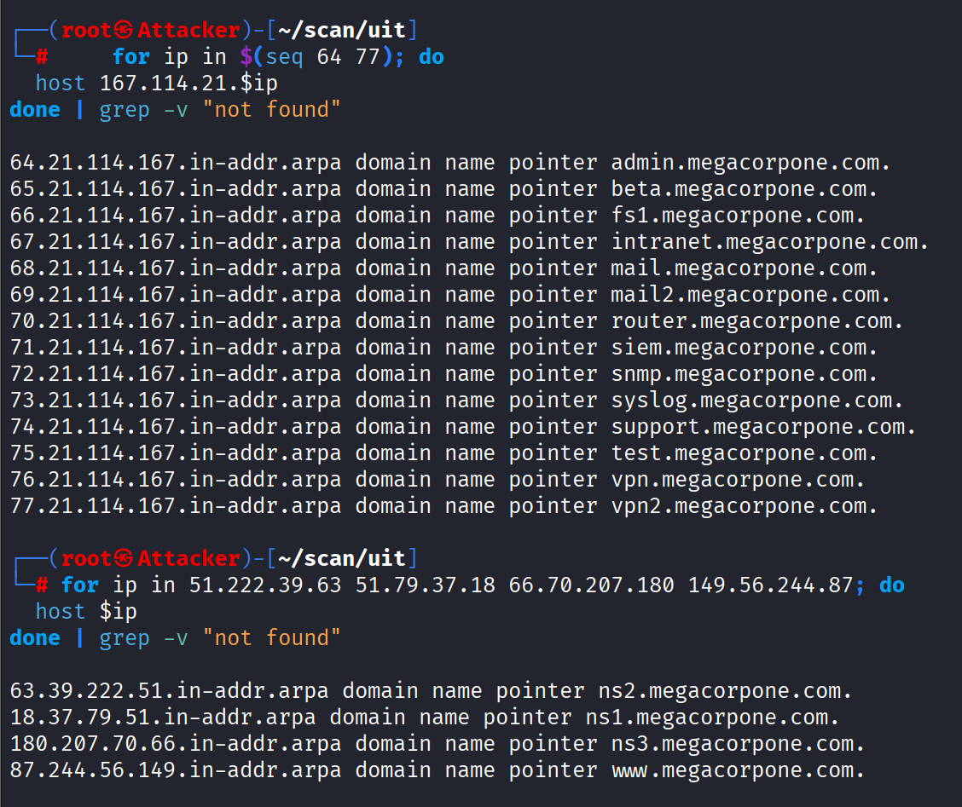
The PTR records revealed several internal and service-related hostnames such as admin, intranet, vpn, siem, and mail, suggesting the presence of critical infrastructure components within the MegaCorp One network.
Although a single IP address can host multiple domains and subdomains through virtual hosting, reverse DNS (PTR) records can only return a single hostname per IP address. PTR records are maintained by the owner of the IP address block and typically represent a descriptive or primary hostname rather than a complete list of all hosted services. Therefore, reverse DNS enumeration may reveal additional infrastructure-related hostnames but cannot enumerate all subdomains associated with an IP.

+ DNS Zone Transfers
Zone Transfer is a database copy between related DNS servers where the zone file is copied from the Master DNS Server to the Slave DNS Server. The zone file contains a list of all DNS names configured for that zone. Zone transfer is only allowed for authorized Slave DNS servers, but many administrators misconfigure DNS servers, and in this case, anyone requesting a copy of the zone will often receive a return result. This is tantamount to giving hackers a complete list of the organization's domain names. All the names, addresses, and functions of the servers could be exposed. A successful zone transfer does not directly lead to network information leaks, although it is a prerequisite, facilitating malicious actors. The command syntax for the host to perform a zone transfer is as follows:
“host -l <domain-name> <dns server address>”
As mentioned above, we know there are three DNS servers managing the megacorpone.com domain: ns1, ns2, and ns3.
Let's try performing a zone transfer on each of these servers. Use the command “host -l” (list zones) to perform a zone transfer:

Unfortunately, the first nameserver, ns1, and the second nameserver, ns3, do not allow DNS zone transfer, so we failed. Try the same with the next nameserver, ns2.
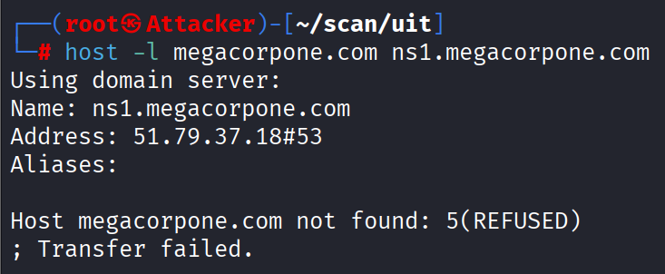
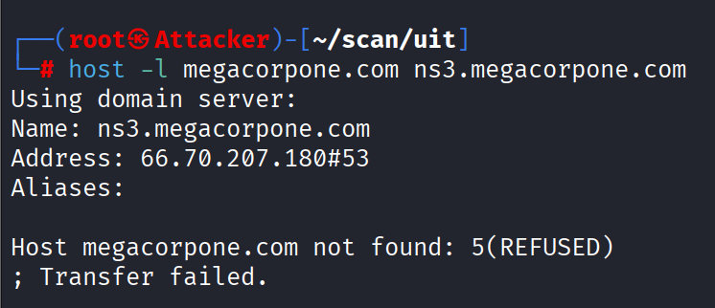
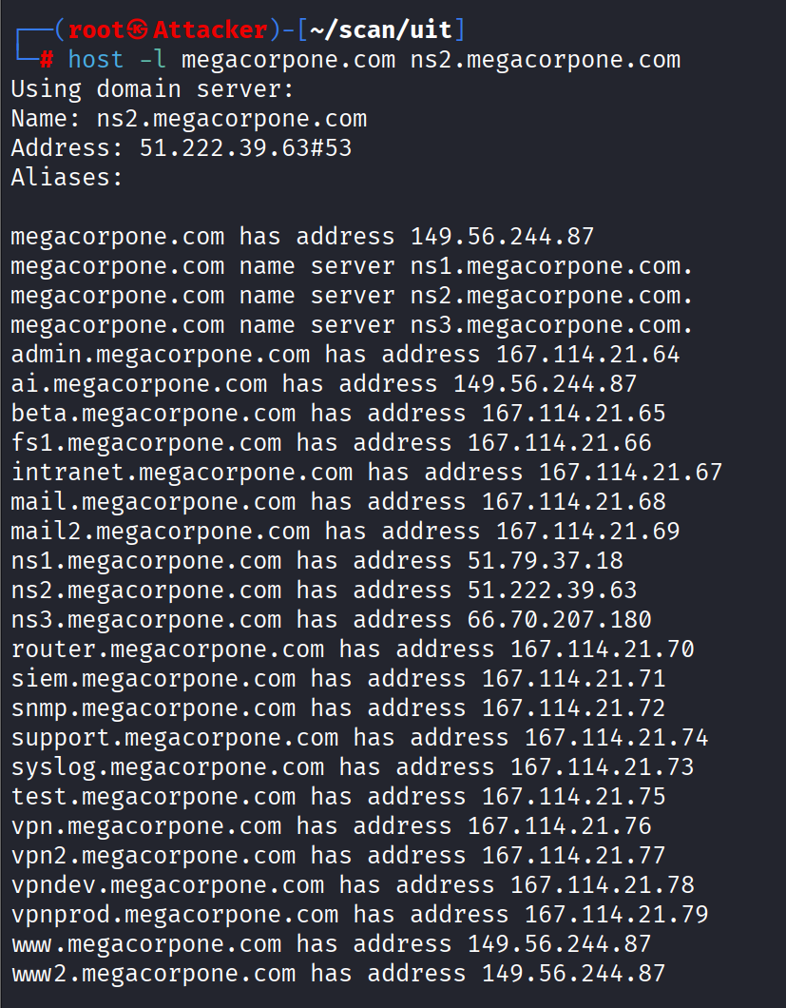
This nameserver allows zone transfer and provides a complete zone file for the domain megacorpone.com, listing the corresponding IP addresses and hostnames.
Trying this with UIT, but all 3 nameserver do not allow DNS zone transfer.
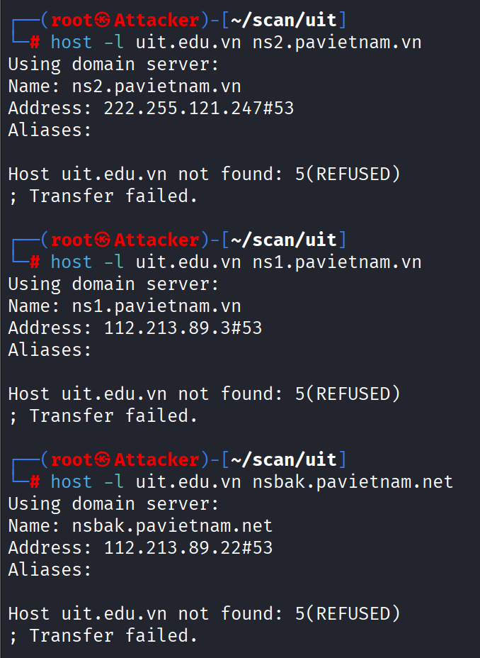
In addition, I know that my University has there own domain name server but it just active when I’m in my University network.
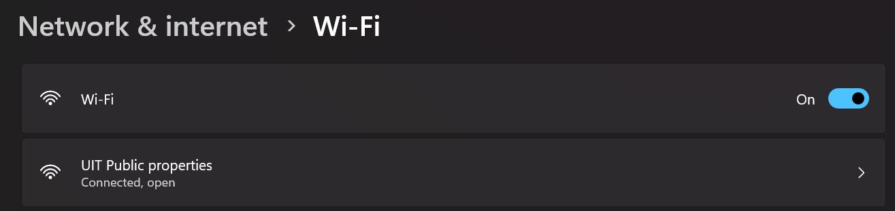
Now, try again the command “host -t ns uit.edu.vn”, we get 2 new nameserver, that is interesting right ?!!!
dns1.uit.edu.vn, and dns2.uit.edu.vn are 2 nameserver in my University network
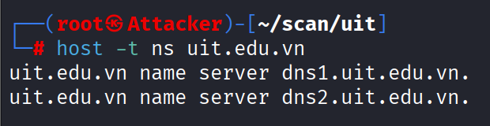
Now try the DNS zone transfer to see if one of these allow.
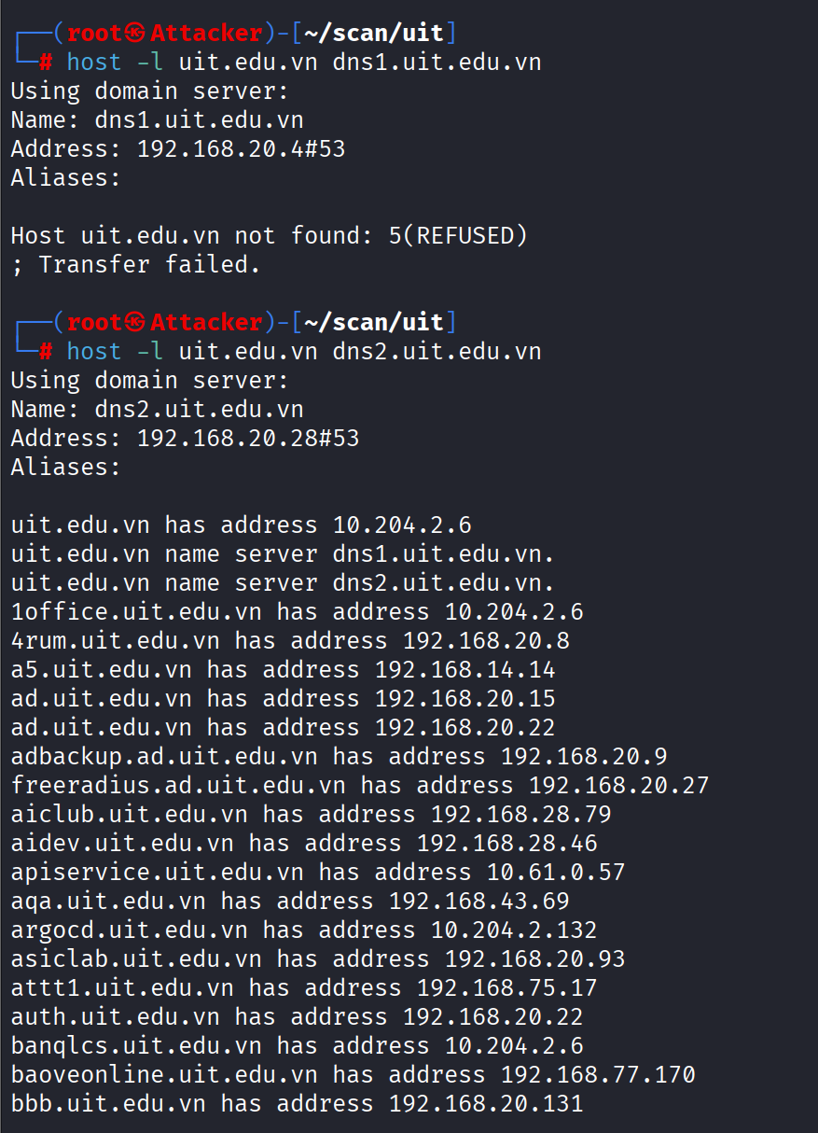
…ETC
We can see that dns1.uit.edu.vn does not allow DNS zone transfer, but dns2.uit.edu.vn allow the DNS zone transfer. So I got a copy of the zone, this allow me to know all the real hostnames of UIT.
The domain uit.edu.vn implements a Split DNS (Split-Horizon DNS) architecture, in which DNS responses differ depending on the source of the query. When DNS queries are issued from within the university’s internal network, the domain resolves to private IP addresses (e.g., 10.x.x.x), enabling access to internal services and infrastructure that are not reachable from the public Internet. In contrast, DNS queries originating from external networks receive public IP addresses responses, effectively concealing internal hostnames and network topology. This design enhances security by reducing the exposure of internal systems while maintaining operational functionality for internal users. However, misconfigurations such as allowing DNS zone transfers on internal name servers may weaken this protection by potentially exposing internal hostnames to unauthorized attackers who gain access to the internal network.
Also, one more interesting thing is that local nameserver of UIT does not use wildcard DNS, so when I type random host, it did not return IP address for that instaed of it return NXDOMAIN.
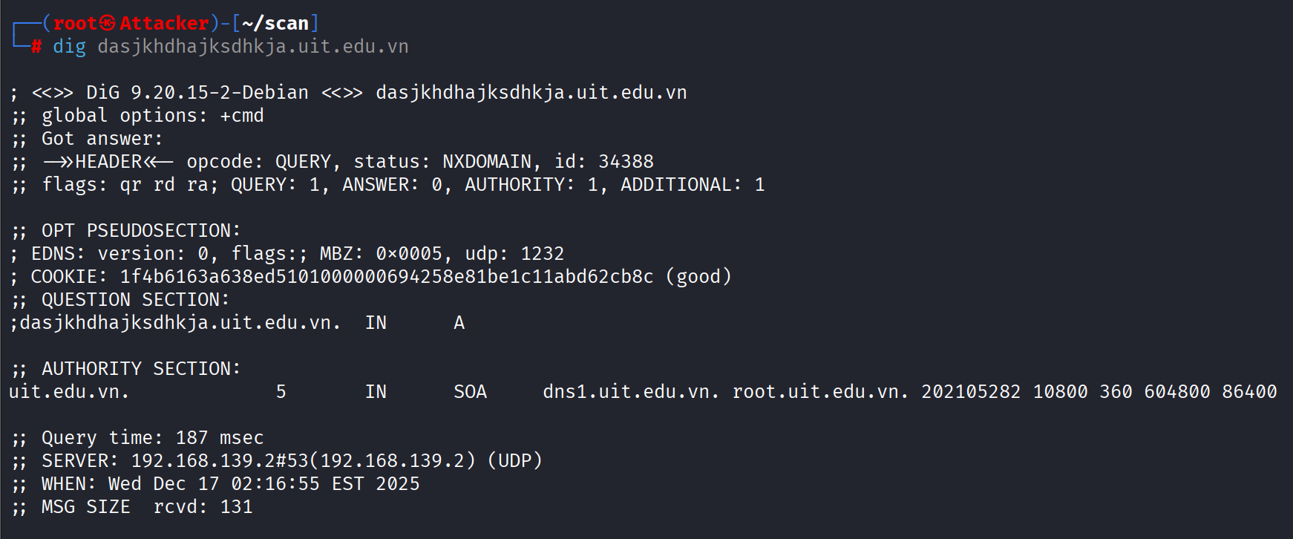
The email of the administrator of this zone is root@uit.edu.vn

Task 10: Write a Bash script to list the nameservers of the member units of the Vietnam National University Ho Chi Minh City (hcmus.edu.vn, hcmussh.edu.vn, uit.edu.vn, hcmut.edu.vn, hcmiu.edu.vn, uel.edu.vn, hcmier.edu.vn, vnuhcm.edu.vn) and perform zone transfers corresponding to the found nameservers.
This is the bash script that I used:
#!/bin/bash
QUERY_NAMESERVER="8.8.8.8" # DNS server để query
QUERY_DELAY="0.5" # Độ trễ giữa các query (có thể là 0.1, 0.5, 1, v.v.)
SHOW_SOA=1 # Hiển thị SOA record? 1=yes, 0=no
SHOW_HEADERS=1 # Hiển thị tiêu đề? 1=yes, 0=no
# Hàm kiểm tra domain format
validate_domain() {
local domain="$1"
# Bỏ khoảng trắng
domain=$(echo "$domain" | xargs)
# Regex kiểm tra domain cơ bản
if [[ "$domain" =~ ^[a-zA-Z0-9]([a-zA-Z0-9\-]{0,61}[a-zA-Z0-9])?(\.[a-zA-Z]{2,})+$ ]] ||
[[ "$domain" =~ ^[0-9]{1,3}\.[0-9]{1,3}\.[0-9]{1,3}\.[0-9]{1,3}$ ]] ||
[[ "$domain" =~ ^.*\.in-addr\.arpa$ ]] ||
[[ "$domain" =~ ^.*\.ip6\.arpa$ ]]; then
return 0
else
return 1
fi
}
# Hàm lấy SOA record
get_soa() {
local domain="$1"
local result=""
result=$(dig @"$QUERY_NAMESERVER" "$domain" SOA +short +time=3 +tries=2 2>/dev/null | head -1)
if [ -n "$result" ]; then
echo "$result"
else
echo "NOT_FOUND"
fi
}
# Hàm lấy NS records
get_ns() {
local domain="$1"
local result=""
result=$(dig @"$QUERY_NAMESERVER" "$domain" NS +short +time=3 +tries=2 2>/dev/null)
if [ -n "$result" ]; then
echo "$result" | sort
else
echo "NOT_FOUND"
fi
}
# Hàm lấy tất cả thông tin DNS
get_dns_info() {
local domain="$1"
echo "=== Domain: $domain ==="
# Lấy SOA nếu được cấu hình
if [ $SHOW_SOA -eq 1 ]; then
echo "SOA Record:"
get_soa "$domain"
echo ""
fi
# Lấy NS records
echo "NS Records:"
get_ns "$domain"
echo ""
}
# Kiểm tra tham số
if [ "$1" == "" ]; then
echo "USAGE: $0 <domain-or-file>"
echo ""
echo "Examples:"
echo " $0 example.com # Check single domain"
echo " $0 domains.txt # Check multiple domains from file"
echo " $0 \"domain1.com domain2.com\" # Check multiple domains"
echo ""
echo "File format: one domain per line, comments start with #"
exit 1
fi
INPUT="$1"
# Hiển thị headers nếu được cấu hình
if [ $SHOW_HEADERS -eq 1 ]; then
echo "================================================"
echo "DNS Nameserver Scanner"
echo "Query Server: $QUERY_NAMESERVER"
echo "================================================"
echo ""
fi
# Xử lý input
if [ -f "$INPUT" ]; then
# Input là file
echo "Reading domains from file: $INPUT"
echo ""
total=0
while IFS= read -r LINE || [ -n "$LINE" ]; do
# Bỏ comment và khoảng trắng
DOMAIN=$(echo "$LINE" | sed 's/#.*//; s/^[[:space:]]*//; s/[[:space:]]*$//')
# Bỏ qua dòng trống
[ -z "$DOMAIN" ] && continue
# Validate domain
if ! validate_domain "$DOMAIN"; then
echo "[WARNING] Skipping invalid domain format: $DOMAIN"
continue
fi
# Lấy thông tin DNS
get_dns_info "$DOMAIN"
((total++))
# Độ trễ giữa các query
if [ $(echo "$QUERY_DELAY > 0" | bc -l 2>/dev/null || echo 0) -eq 1 ]; then
sleep "$QUERY_DELAY"
fi
done < "$INPUT"
echo "================================================"
echo "Completed: $total domains processed"
else
# Input là domain hoặc danh sách domain
if echo "$INPUT" | grep -q " "; then
# Nhiều domain trong command line
echo "Checking multiple domains from command line"
echo ""
total=0
for DOMAIN in $INPUT; do
# Validate domain
if ! validate_domain "$DOMAIN"; then
echo "[WARNING] Skipping invalid domain format: $DOMAIN"
continue
fi
# Lấy thông tin DNS
get_dns_info "$DOMAIN"
((total++))
# Độ trễ giữa các query
if [ $(echo "$QUERY_DELAY > 0" | bc -l 2>/dev/null || echo 0) -eq 1 ]; then
sleep "$QUERY_DELAY"
fi
done
echo "================================================"
echo "Completed: $total domains processed"
else
# Một domain duy nhất
DOMAIN="$INPUT"
# Validate domain
if ! validate_domain "$DOMAIN"; then
echo "[ERROR] Invalid domain format: $DOMAIN"
exit 1
fi
# Lấy thông tin DNS
get_dns_info "$DOMAIN"
fi
Fi

After running this script, I get all the nameserver and SOA of the member units of the Vietnam National University Ho Chi Minh City. As show below.
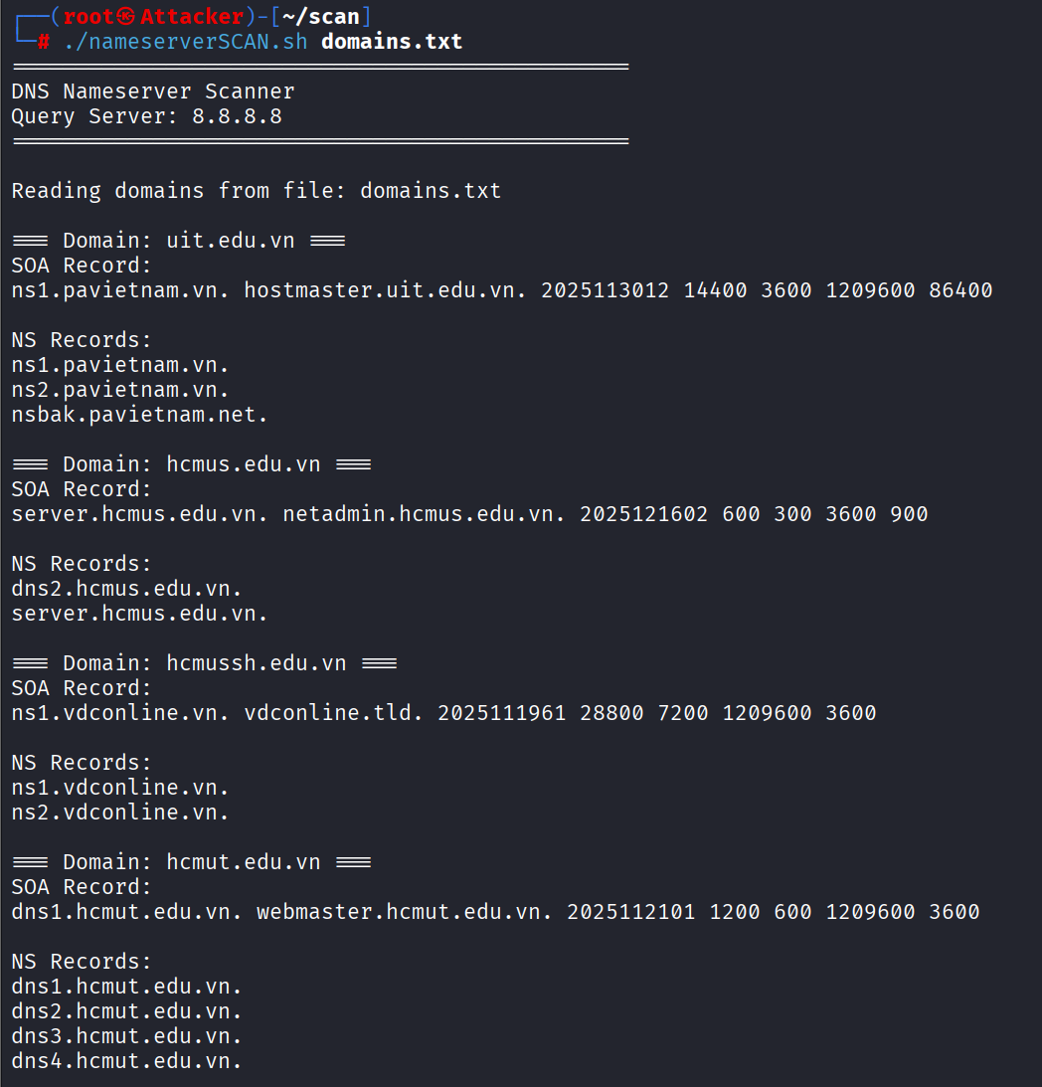
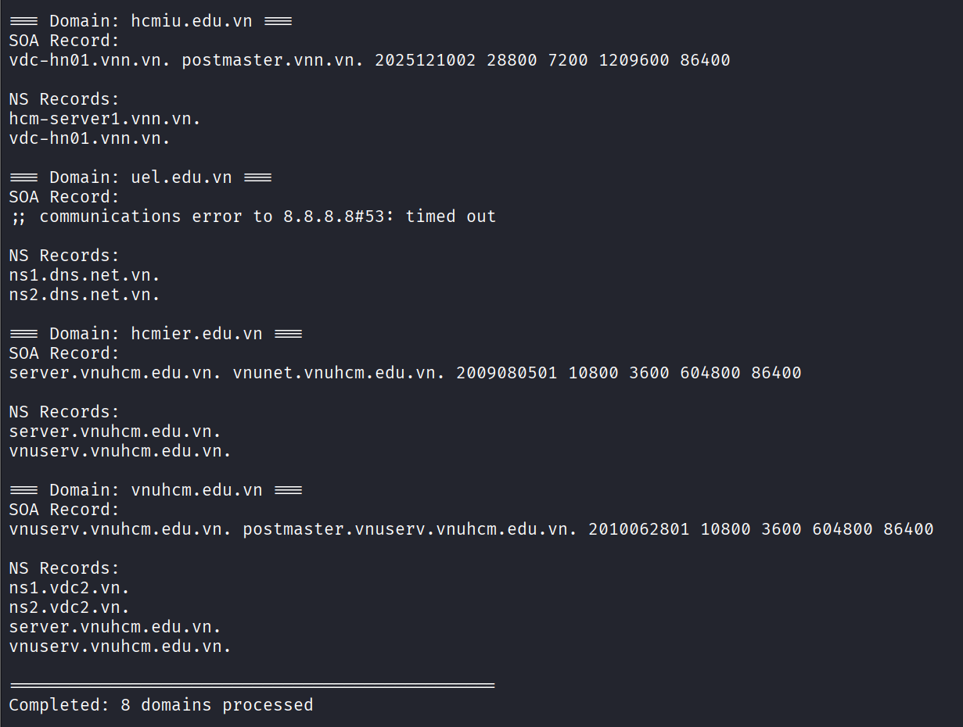
In this I use google DNS server to query so I get the external NS of UIT which ns1.pavietnam.com,…not the one that when I use the internal UIT network DNS. I really curious about the other Universities of the Vietnam National University Ho Chi Minh City, will they have split DNS like UIT or not ? I will find out when I visit these Universities.

2.2. Port Scanning
Port scanning is the process of examining TCP or UDP ports on a remote machine with the aim of
detecting services running on the target machine and potential attack possibilities associated with those services.
It is essential to understand the meaning of port scanning, as well as the impact of performing port scans. Due to the amount of traffic that some scan processes can generate, along with their intrusive nature, blindly scanning ports can have negative impacts on the target system or client network, such as overloading the server and network link or triggering the IDS. Incorrect scans can lead to downtime for clients.

- Scan for vulnerabilities using the Nessus tool.
Nessus is a popular vulnerability scanning tool, supporting over 130,000 plugins. Initially, Nessus was developed as an open-source application; however, in 2005, the source code was closed. This shift to a closed-source model led to the development of forks of open-source projects, one of which is OpenVAS.
  - Install and configure Nessus
Although Nessus is not in the Kali repository, we can download the 64-bit .deb file from the Tenable homepage: https://www.tenable.com/downloads/nessus
After ensuring the integrity of the file is preserved during the download process, install it using the apt command:
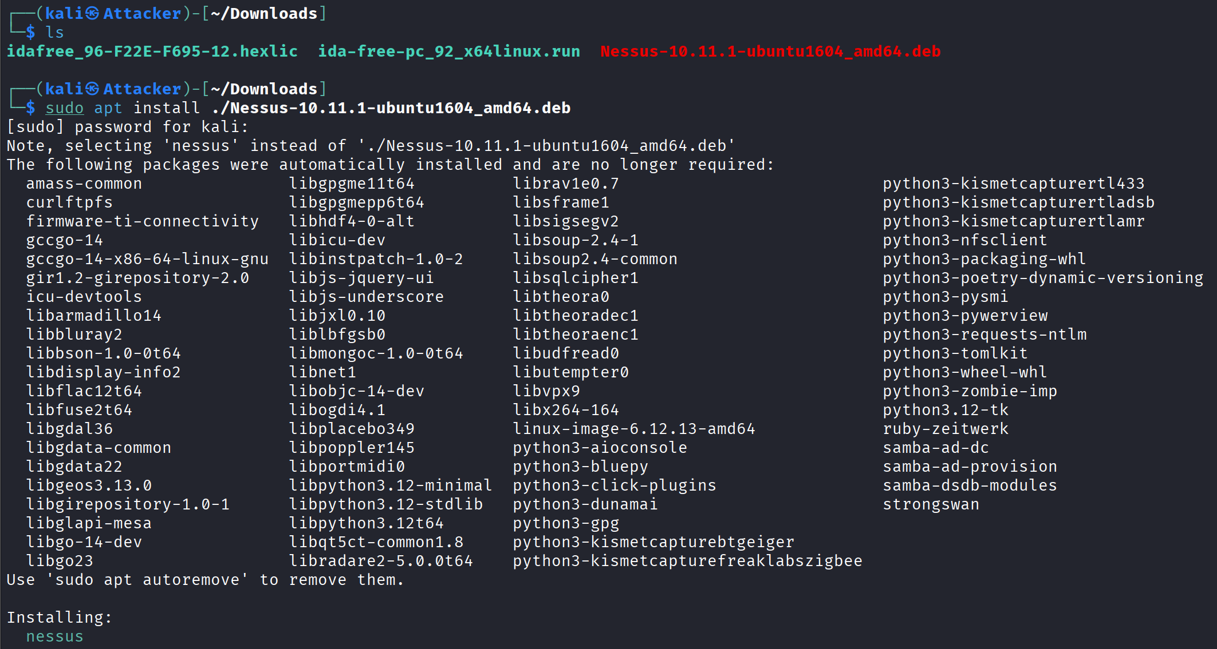
After successful installation, start the Nessusd service.
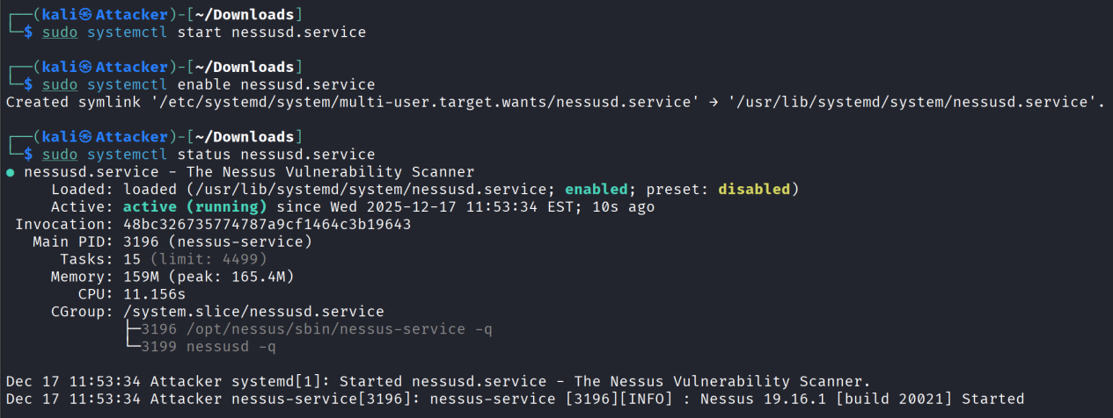
After starting Nessus, open your browser and go to the address https://localhost:8834/.
We will be notified of a certificate error; select Advanced… -> Accept the Risk and Continue.
After the page loads, we can we the Nessus welcome page, we should leave the register offline uncheck, then continue.
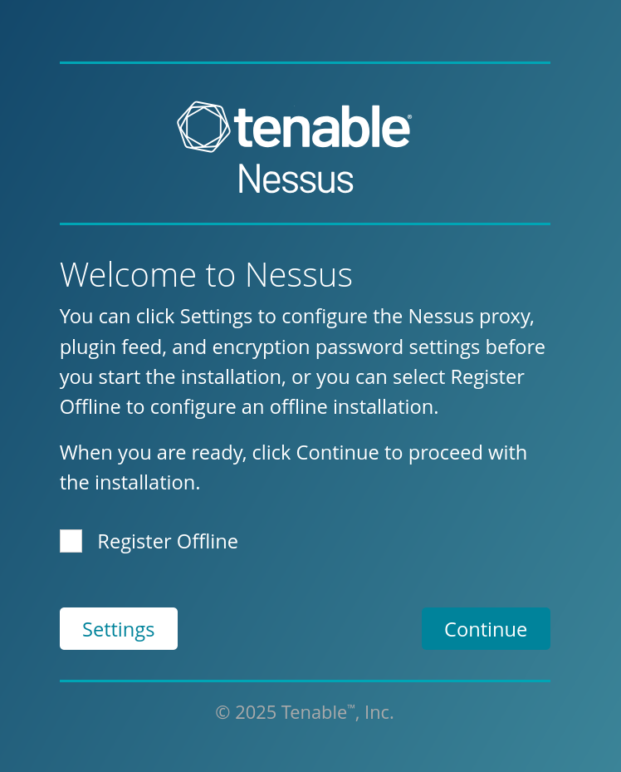

After the page loads, we are prompted to choose the version of Nessus we want to use.
In this case, select Nessus Essentials, then select Continue.
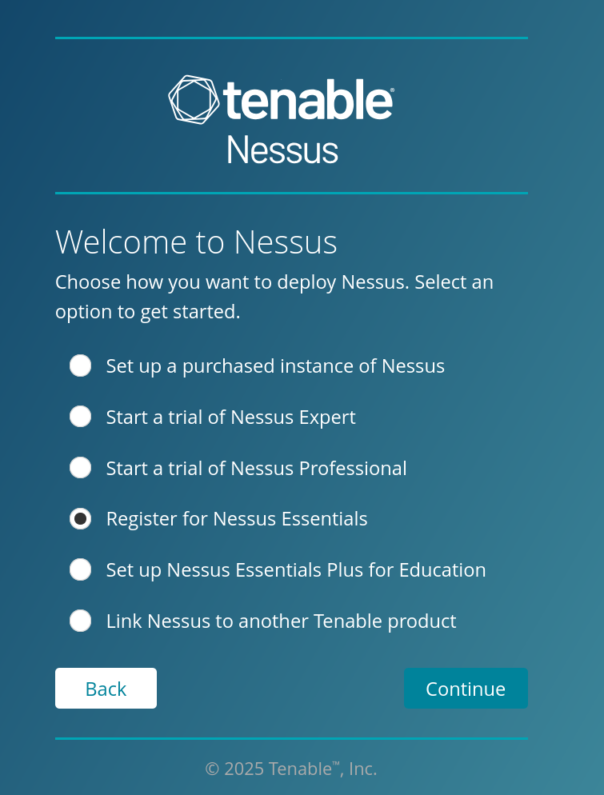

Next, enter the required information. Note that you must enter the correct email address so that Nessus can send the Activation code to your email address, then click Email.
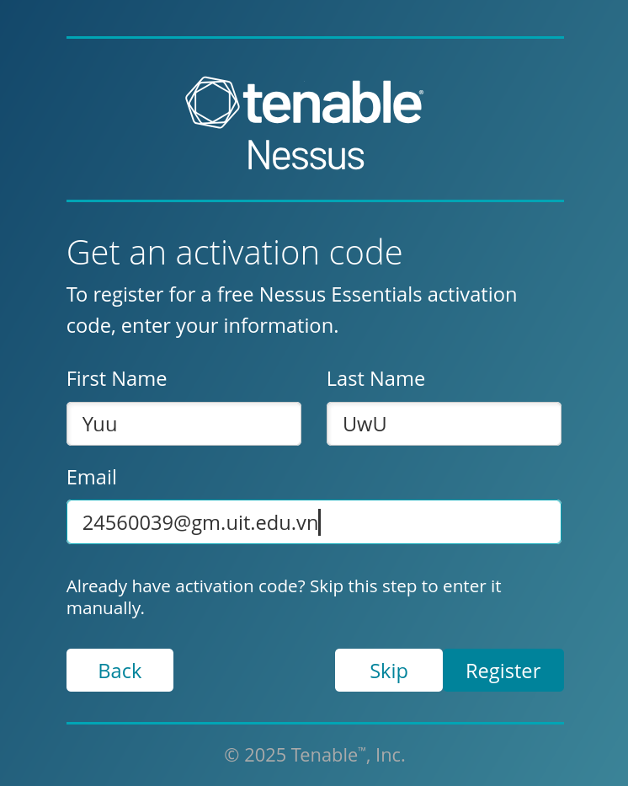

After receiving the verification in the email, click verify and wait for it, then after successfully verifying, we can click verify in Nessus.
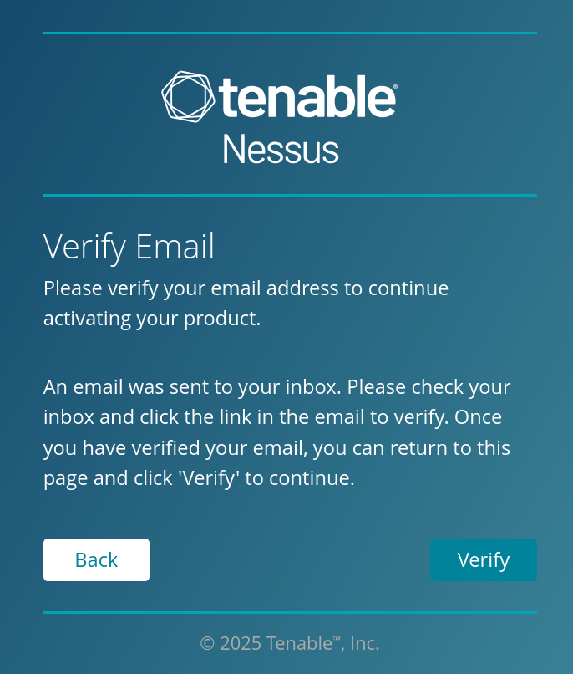

After the verification step, we will get the license information.
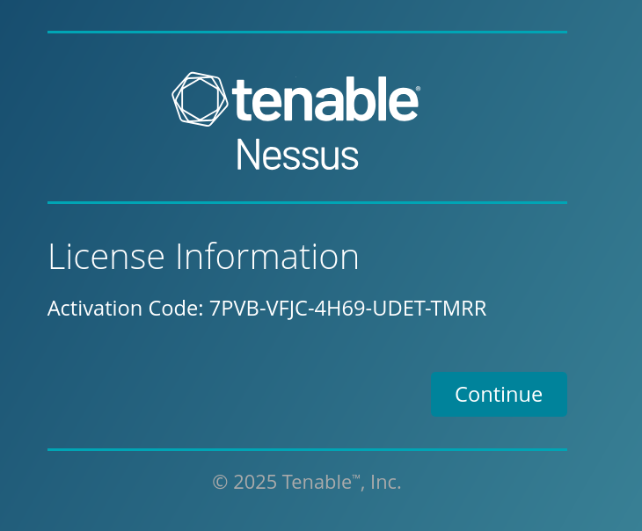
Now that Nessus is activated, the next step is to create a Nessus administrator account. Enter your username and password, and then click Submit.
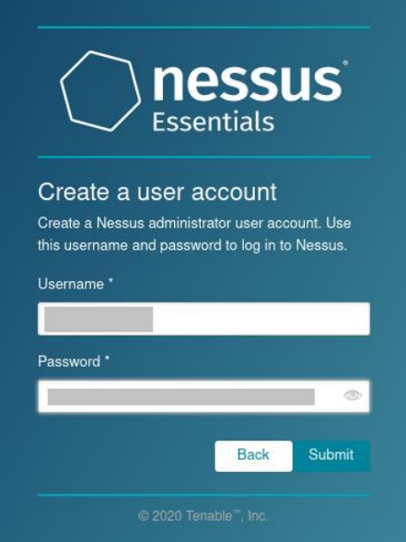
Username: YuuUwU
Password: Whyyouwannaknow3
Finally, wait for the plugin update and installation process to complete. This process will take quite a long time.
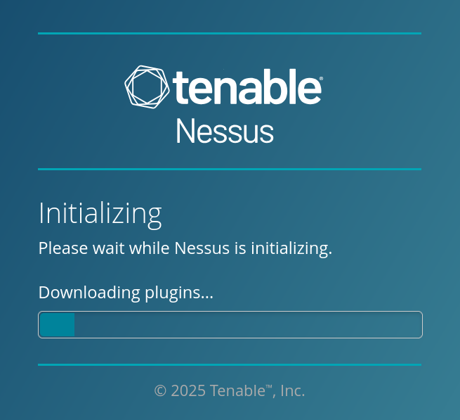
After a while, Nessus finish installing, we can see its dashboard.
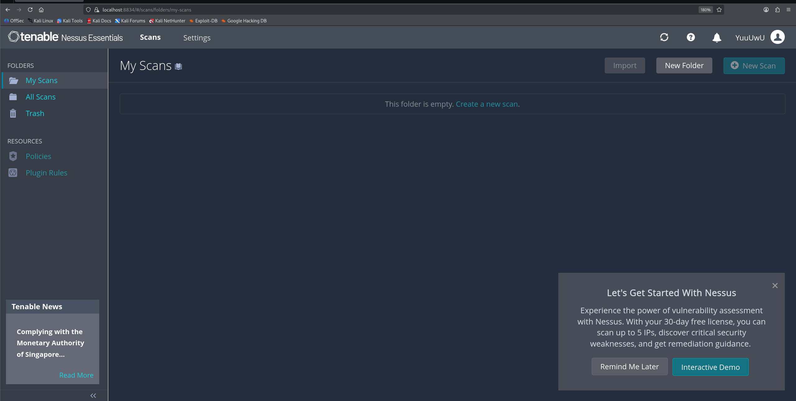

Let’s perform the first scan. To begin, click the New Scan button.
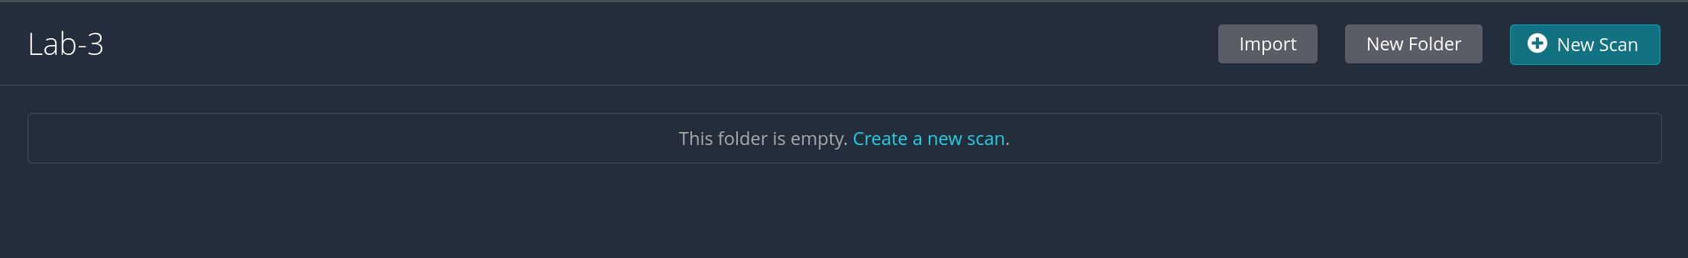
In this perform, I will use Basic Network Scan.
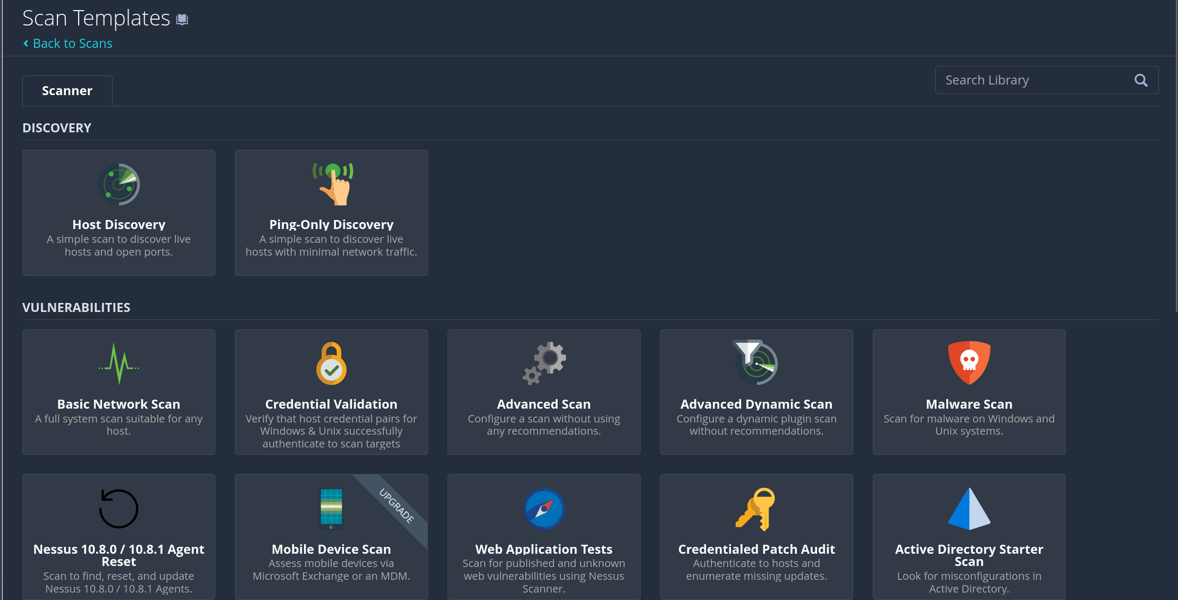
Nessus will display the scan configuration settings screen with two required parameters: name and
list of targets to scan. Nessus supports target declaration using IP addresses, IP address ranges; FQDN lists or IPs separated by commas.
For example, in this practice exercise, we will scan a Metasploitable2 machine with IP address 192.168... We will enter “Metasploitable2 – Basic” in the Name field and the IP address in the Targets field.

